Default Report  
*User satisfaction with a service encounter through a voice assistant (5May)*  
**July 15th 2020, 12:46 am MDT**

**Q1 - …but first let's make sure you should indeed participate in this survey! We are looking for respondents who recently experienced a longer conversation with a voice assistant. A longer conversation, for us, consisted of 4 or more turns. Here's an example: YES 1. You: "Hey Siri, I would like to book a hotel in London" 2. Voice assistant: "What about the Tower hotel?" 3. You: "Is it available from 12 to 15 August?” 4. Voice assistant: "I’m not sure about that. Do you want me to call the hotel for you?” 5. You: "Yes please" NO 1. You: "Hey siri, what time is it?" 2. Voice assistant: "It's 5 o'clock" Have you ever had a conversation with a voice assistant that consisted of 4 or more turns?**

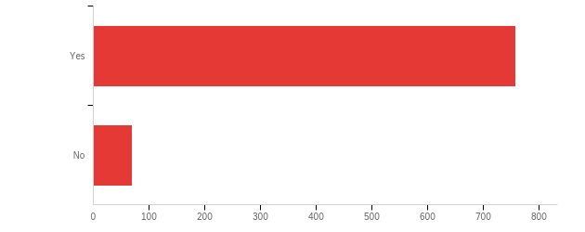

|  |  |  |  |  |  |  |  |
| --- | --- | --- | --- | --- | --- | --- | --- |
| # | Field | Minimum | Maximum | Mean | Std Deviation | Variance | Count |
| 1 | …but first let's make sure you should indeed participate in this survey! We are looking for respondents who recently experienced a longer conversation with a voice assistant. A longer conversation, for us, consisted of 4 or more turns. Here's an example: YES 1. You: &quot;Hey Siri, I would like to book a hotel in London&quot; 2. Voice assistant: &quot;What about the Tower hotel?&quot; 3. You: &quot;Is it available from 12 to 15 August?” 4. Voice assistant: &quot;I’m not sure about that. Do you want me to call the hotel for you?” 5. You: &quot;Yes please&quot; NO 1. You: &quot;Hey siri, what time is it?&quot; 2. Voice assistant: &quot;It's 5 o'clock&quot; Have you ever had a conversation with a voice assistant that consisted of 4 or more turns? | 1.00 | 2.00 | 1.08 | 0.28 | 0.08 | 828 |

|  |  |  |  |
| --- | --- | --- | --- |
| # | Answer | % | Count |
| 1 | Yes | 91.67% | 759 |
| 2 | No | 8.33% | 69 |
|  | Total | 100% | 828 |

**QID1 - Which of the following voice assistants did you use at least once (multiple answers possible)?**

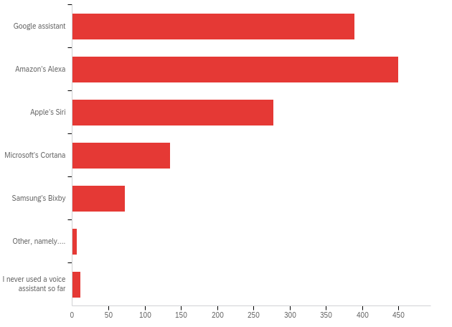

|  |  |  |  |
| --- | --- | --- | --- |
| # | Answer | % | Count |
| 1 | Google assistant | 29.04% | 390 |
| 2 | Amazon’s Alexa | 33.51% | 450 |
| 3 | Apple’s Siri | 20.70% | 278 |
| 4 | Microsoft’s Cortana | 10.05% | 135 |
| 5 | Samsung’s Bixby | 5.44% | 73 |
| 6 | Other, namely&hellip;. | 0.45% | 6 |
| 7 | I never used a voice assistant so far | 0.82% | 11 |
|  | Total | 100% | 1343 |

QID1_6_TEXT - Other, namely….

|  |
| --- |
| Other, namely…. - Text |
| MTRUCK |
| Google Mini Home |
| blackberry |
| c |
| x |
| x |

**Q48 - And which of these voice assistants do you currently use most (one answer possible)?**

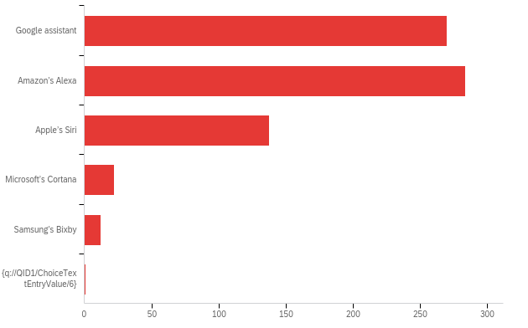

|  |  |  |  |  |  |  |  |
| --- | --- | --- | --- | --- | --- | --- | --- |
| # | Field | Minimum | Maximum | Mean | Std Deviation | Variance | Count |
| 1 | And which of these voice assistants do you currently use most (one answer possible)? | 7.00 | 12.00 | 7.93 | 0.92 | 0.85 | 727 |

|  |  |  |  |
| --- | --- | --- | --- |
| # | Answer | % | Count |
| 7 | Google assistant | 37.14% | 270 |
| 8 | Amazon’s Alexa | 39.06% | 284 |
| 9 | Apple’s Siri | 18.98% | 138 |
| 10 | Microsoft’s Cortana | 3.03% | 22 |
| 11 | Samsung’s Bixby | 1.65% | 12 |
| 12 | ${q://QID1/ChoiceTextEntryValue/6} | 0.14% | 1 |
|  | Total | 100% | 727 |

**Q47 - From hereon we will address this most used voice assistant as your favorite voice assistant. Your most favorite voice assistant, hence, is: [QID71-ChoiceGroup-SelectedChoices].**



|  |  |  |  |  |  |  |  |
| --- | --- | --- | --- | --- | --- | --- | --- |
| # | Field | Minimum | Maximum | Mean | Std Deviation | Variance | Count |
| 1 | From hereon we will address this most used voice assistant as your favorite voice assistant. Your most favorite voice assistant, hence, is: [QID71-ChoiceGroup-SelectedChoices]. | 0.00 | 0.00 | 0.00 | 0.00 | 0.00 | 0 |

|  |  |  |
| --- | --- | --- |
| Answer | % | Count |
| Total | 100% | undefined |

**QID13 - On which device do you mostly use [QID71-ChoiceGroup-SelectedChoices]?**

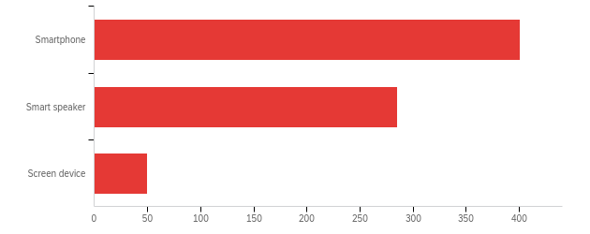

|  |  |  |  |  |  |  |  |
| --- | --- | --- | --- | --- | --- | --- | --- |
| # | Field | Minimum | Maximum | Mean | Std Deviation | Variance | Count |
| 1 | On which device do you mostly use [QID71-ChoiceGroup-SelectedChoices]? | 1.00 | 3.00 | 1.52 | 0.62 | 0.39 | 736 |

|  |  |  |  |
| --- | --- | --- | --- |
| # | Answer | % | Count |
| 1 | Smartphone | 54.48% | 401 |
| 2 | Smart speaker | 38.72% | 285 |
| 3 | Screen device | 6.79% | 50 |
|  | Total | 100% | 736 |

Unable to export widget. Please contact Qualtrics Support.

**QID55 - During which part of the week do you mostly use [QID71-ChoiceGroup-SelectedChoices]?**

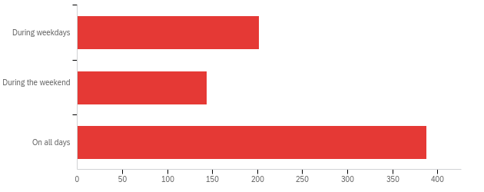

|  |  |  |  |  |  |  |  |
| --- | --- | --- | --- | --- | --- | --- | --- |
| # | Field | Minimum | Maximum | Mean | Std Deviation | Variance | Count |
| 1 | During which part of the week do you mostly use [QID71-ChoiceGroup-SelectedChoices]? | 1.00 | 3.00 | 2.25 | 0.86 | 0.74 | 734 |

|  |  |  |  |
| --- | --- | --- | --- |
| # | Answer | % | Count |
| 1 | During weekdays | 27.52% | 202 |
| 2 | During the weekend | 19.62% | 144 |
| 3 | On all days | 52.86% | 388 |
|  | Total | 100% | 734 |

**QID14 - In a normal week, how many days do you use [QID71-ChoiceGroup-SelectedChoices]?**

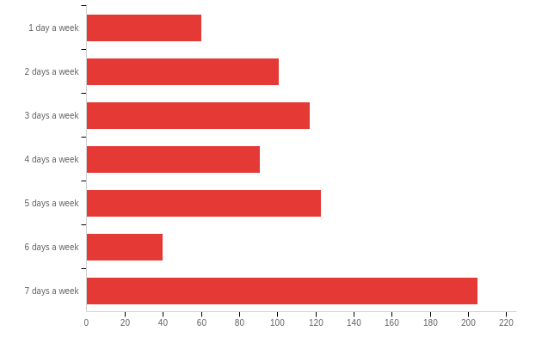

|  |  |  |  |  |  |  |  |
| --- | --- | --- | --- | --- | --- | --- | --- |
| # | Field | Minimum | Maximum | Mean | Std Deviation | Variance | Count |
| 1 | In a normal week, how many days do you use [QID71-ChoiceGroup-SelectedChoices]? | 1.00 | 7.00 | 4.43 | 2.03 | 4.14 | 737 |

|  |  |  |  |
| --- | --- | --- | --- |
| # | Answer | % | Count |
| 1 | 1 day a week | 8.14% | 60 |
| 2 | 2 days a week | 13.70% | 101 |
| 3 | 3 days a week | 15.88% | 117 |
| 4 | 4 days a week | 12.35% | 91 |
| 5 | 5 days a week | 16.69% | 123 |
| 6 | 6 days a week | 5.43% | 40 |
| 7 | 7 days a week | 27.82% | 205 |
|  | Total | 100% | 737 |

**QID10 - On a normal day, how many times do you use [QID71-ChoiceGroup-SelectedChoices]?**

|  |
| --- |
| times a day |
| 2 |
| 6 |
| 9 |
| 4 |
| 2 |
| 2 |
| 1 |
| 3 |
| 15 |
| 2 |
| 3 |
| 5 |
| 15 |
| 5 |
| 7 |
| 7 |
| 5 |
| 4 |
| 5 |
| 2 |
| 60 |
| 3 |
| 2 |
| 3 |
| 15 |
| 3 |
| 4 |
| 10 |
| 5 |
| 9 |
| 3 |
| 1 |
| 3 |
| 20 |
| 6 |
| 6 |
| 13 |
| 1 |
| 1 |
| 3 |
| 10 |
| 19 |
| 3 |
| 11 |
| 20 |
| 2 |
| 12 |
| 2 |
| 5 |
| 10 |
| 5 |
| 2 |
| 10 |
| 1 |
| 17 |
| 5 |
| 2 |
| 4 |
| 10 |
| 8 |
| 4 |
| 2 |
| 40 |
| 6 |
| 3 |
| 2 |
| 5 |
| 5 |
| 4 |
| 10 |
| 5 |
| 10 |
| 4 |
| 5 |
| 1 |
| 1 |
| 4 |
| 10 |
| 8 |
| 4 |
| 10 |
| 2 |
| 5 |
| 3 |
| 52 |
| 4 |
| 2 |
| 10 |
| 12 |
| 1 |
| 3 |
| 20 |
| 3 |
| 5 |
| 3 |
| 3 |
| 4 |
| 15 |
| 9 |
| 5 |
| 1 |
| 3 |
| 4 |
| 1 |
| 5 |
| 20 |
| 0 |
| 3 |
| 15 |
| 35 |
| 2 |
| 2 |
| 2 |
| 4 |
| 4 |
| 2 |
| 2 |
| 2 |
| 4 |
| 1 |
| 3 |
| 5 |
| 11 |
| 10 |
| 3 |
| 3 |
| 25 |
| 4 |
| 6 |
| 2 |
| 60 |
| 1 |
| 6 |
| 1 |
| 2 |
| 0 |
| 4 |
| 8 |
| 4 |
| 5 |
| 6 |
| 4 |
| 2 |
| 3 |
| 4 |
| 3 |
| 2 |
| 48 |
| 10 |
| 5 |
| 4 |
| 1 |
| 1 |
| 7 |
| 23 |
| 7 |
| 6 |
| 3 |
| 5 |
| 10 |
| 5 |
| 7 |
| 2 |
| 5 |
| 2 |
| 7 |
| 2 |
| 1 |
| 2 |
| 5 |
| 8 |
| 1 |
| 5 |
| 20 |
| 20 |
| 3 |
| 10 |
| 5 |
| 5 |
| 8 |
| 4 |
| 3 |
| 4 |
| 2 |
| 4 |
| 3 |
| 65 |
| 3 |
| 2 |
| 1 |
| 10 |
| 3 |
| 5 |
| 2 |
| 5 |
| 5 |
| 2 |
| 10 |
| 2 |
| 5 |
| 4 |
| 4 |
| 4 |
| 2 |
| 8 |
| 1 |
| 1 |
| 1 |
| 10 |
| 4 |
| 10 |
| 3 |
| 10 |
| 4 |
| 5 |
| 5 |
| 4 |
| 3 |
| 14 |
| 4 |
| 26 |
| 2 |
| 4 |
| 2 |
| 1 |
| 5 |
| 5 |
| 5 |
| 50 |
| 15 |
| 10 |
| 1 |
| 10 |
| 5 |
| 5 |
| 5 |
| 6 |
| 10 |
| 3 |
| 1 |
| 3 |
| 5 |
| 5 |
| 3 |
| 3 |
| 5 |
| 2 |
| 10 |
| 5 |
| 3 |
| 8 |
| 3 |
| 3 |
| 5 |
| 3 |
| 3 |
| 10 |
| 5 |
| 2 |
| 2 |
| 3 |
| 4 |
| 5 |
| 3 |
| 7 |
| 8 |
| 2 |
| 5 |
| 22 |
| 4 |
| 3 |
| 2 |
| 5 |
| 4 |
| 30 |
| 5 |
| 5 |
| 1 |
| 50 |
| 2 |
| 3 |
| 5 |
| 4 |
| 0 |
| 14 |
| 2 |
| 3 |
| 2 |
| 1 |
| 8 |
| 12 |
| 5 |
| 1 |
| 2 |
| 2 |
| 1 |
| 20 |
| 20 |
| 3 |
| 4 |
| 3 |
| 50 |
| 2 |
| 2 |
| 20 |
| 5 |
| 1 |
| 15 |
| 5 |
| 12 |
| 1 |
| 5 |
| 1 |
| 6 |
| 3 |
| 3 |
| 5 |
| 7 |
| 1 |
| 1130 |
| 1 |
| 3 |
| 25 |
| 6 |
| 1 |
| 50 |
| 3 |
| 3 |
| 2 |
| 4 |
| 5 |
| 0 |
| 3 |
| 15 |
| 8 |
| 5 |
| 4 |
| 2 |
| 4 |
| 5 |
| 3 |
| 10 |
| 2 |
| 10 |
| 1 |
| 0 |
| 10 |
| 4 |
| 1 |
| 10 |
| 2 |
| 5 |
| 3 |
| 3 |
| 5 |
| 5 |
| 0 |
| 2 |
| 3 |
| 5 |
| 4 |
| 3 |
| 5 |
| 5 |
| 2 |
| 2 |
| 2 |
| 10 |
| 5 |
| 3 |
| 3 |
| 4 |
| 2 |
| 15 |
| 5 |
| 5 |
| 5 |
| 2 |
| 9 |
| 9 |
| 9 |
| 112 |
| 1 |
| once or twice |
| 6 |
| 3 |
| 8 |
| 5 |
| 2 |
| one |
| 3 |
| 1 |
| 1 |
| 3 |
| 4 |
| 5 |
| 4 |
| 2 |
| 1 |
| 5 |
| 10 |
| 3 |
| 2 |
| 1 |
| 4 |
| 2 |
| 2 |
| 2 |
| 2 |
| 15 |
| 15 |
| 12 |
| 4 |
| 2 |
| 2 |
| 7 |
| 6 |
| 8 |
| 3 |
| 5 |
| 2 |
| 6 |
| 2 |
| 2 |
| 2-3 |
| 1 |
| 10 |
| 15 |
| 10 |
| 2 |
| 1 |
| 2 |
| 1 |
| 1 |
| 5 |
| 2 |
| 2 |
| 4 |
| 1 |
| 2 |
| 3 |
| 5 |
| 2 |
| 5 |
| 1 |
| 1 |
| 2 |
| 3 |
| 3 |
| 10 |
| 4 |
| 2 |
| 3 |
| 3 |
| 3 |
| 50 |
| 2 |
| 5 |
| 5 |
| 2 |
| 4 |
| 3 |
| 3 |
| 10 |
| 10 |
| 2 |
| 2 |
| 3 |
| 5 |
| 1 |
| 4 |
| 3 |
| 5 |
| 1 |
| 10 |
| 5 |
| 10 |
| 7 |
| 10 |
| 1 |
| 2 |
| 2 |
| 2 |
| 3 |
| 5 |
| 3 |
| 5 |
| 1 |
| 30 |
| 1 |
| 2 |
| 2 |
| 25 |
| 3 |
| 1 |
| 2 |
| 2 |
| 10 |
| 1 |
| 2 |
| 10 |
| 4 |
| 3 |
| 3 |
| 4 |
| 3 |
| 5 |
| If for work, I use it multiple times, asking meaning of words and spellings. Then I use it often for directions. So, on a normal day at least 3 times. |
| 3 |
| 10 |
| 4 |
| 10 |
| 2 |
| 3 |
| 2 |
| 5 |
| 2 |
| 20 |
| 10 |
| 6 |
| 100 |
| 3 |
| 5 |
| 4 |
| 4 |
| 4 |
| 5 |
| 2 |
| 3 |
| 3 |
| 2 |
| 5 |
| 2 |
| 1 |
| 0 |
| 3 |
| 9 |
| 3 |
| 2 |
| 15 |
| 2 |
| 3 |
| 2 |
| 5 |
| 3 |
| 3 |
| 20 |
| 5 |
| 1 |
| 3 |
| 1 |
| 2 |
| 5 |
| 5 |
| 5 |
| 2 |
| 10 |
| 1 |
| 10 |
| 2 |
| 10 |
| 2 |
| 1 |
| 3 |
| 3 |
| 4 |
| 4 |
| 6 |
| 4 |
| 2 |
| 3 |
| 2 |
| 3 |
| 5 |
| 3 |
| 1 |
| 3 |
| 2 |
| 3 |
| 6 |
| 5 |
| 3 |
| 5 |
| 3 |
| 8 |
| 3 |
| 3 |
| 3 |
| 20 |
| 1 |
| 2 |
| 7 |
| 5 |
| 4 |
| 2 |
| 15 |
| 5 |
| 5 |
| 5 |
| 20 |
| 4 |
| 1 |
| 2 |
| 15 |
| 10 |
| 1 |
| 1 |
| 1 |
| 5 |
| 10 |
| 2 |
| 3 |
| 5 |
| 2 |
| 3 |
| 4 |
| 1 |
| 14 |
| 4 |
| 2 |
| 3 |
| 5 |
| 12 |
| 4 |
| 2 |
| 2 |
| 5 |
| 1 |
| 2 |
| 2 |
| 2 |
| 2 |
| 3 |
| 3 |
| 4 |
| 10 |
| 1 |
| 3 |
| 5 |
| 2 |
| 2 |
| 3 |
| 1 |
| 3 |
| 5 |
| 3 |
| 1 |
| 3 |
| 1 |
| 1 |
| 3 |
| 2 |
| 3 |
| 6 |
| 5 |
| 2-3 |
| 3 |
| 10 |
| 5 |
| 2 |
| 2 |
| 4 |
| 3 |
| 1 |
| 2 |
| 5 |
| 5 |
| 3 |
| 5 |
| 12 |
| 10 |
| 3 |
| 5 |
| 1 |
| 3 |
| 3 |
| 10 |
| 6 |
| 3 |
| 5 |
| 1 |
| 5 |
| 4 |
| 5 |
| 3 |
| 2 |
| 5 |
| 2 |
| 1 |
| 4 |
| 3 |
| 2 |
| 4 |
| 3 |
| 2 |
| 1 |
| 3 |
| 3 |
| 1 |
| 5 |
| 2 |
| 3 |
| 5 |
| 4 |
| 3 |
| 2 |
| 2 |
| 5 |
| 1-2 |
| 1 |
| 10 |
| 3 |
| 10 |
| 1 |
| 20 |
| 4 |
| 2 |
| 3 |
| 3 |
| 2 |
| 10 |
| 2 |
| 9 |
| 9 |
| 8 |

**QID20 - On a normal day, when do you usually use [QID71-ChoiceGroup-SelectedChoices] (multiple answers are possible)?**

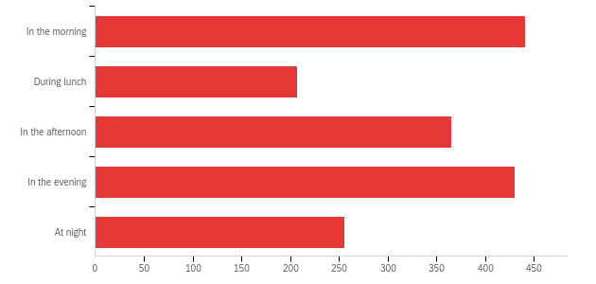

|  |  |  |  |
| --- | --- | --- | --- |
| # | Answer | % | Count |
| 1 | In the morning | 25.96% | 441 |
| 2 | During lunch | 12.18% | 207 |
| 3 | In the afternoon | 21.48% | 365 |
| 4 | In the evening | 25.31% | 430 |
| 5 | At night | 15.07% | 256 |
|  | Total | 100% | 1699 |

**QID24 - Did you ever use [QID71-ChoiceGroup-SelectedChoices] for a service encounter that consisted of a dialogue with 4 or more turns?**

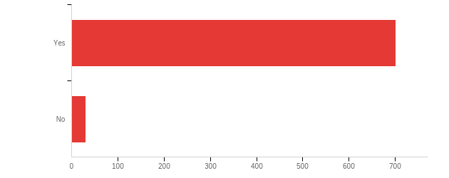

|  |  |  |  |  |  |  |  |
| --- | --- | --- | --- | --- | --- | --- | --- |
| # | Field | Minimum | Maximum | Mean | Std Deviation | Variance | Count |
| 1 | Did you ever use [QID71-ChoiceGroup-SelectedChoices] for a service encounter that consisted of a dialogue with 4 or more turns? | 1.00 | 2.00 | 1.04 | 0.20 | 0.04 | 732 |

|  |  |  |  |
| --- | --- | --- | --- |
| # | Answer | % | Count |
| 1 | Yes | 95.90% | 702 |
| 2 | No | 4.10% | 30 |
|  | Total | 100% | 732 |

**QID27 - My latest service conversation of this type with [QID71-ChoiceGroup-SelectedChoices] was….**

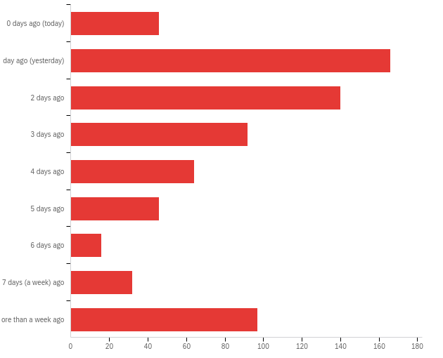

|  |  |  |  |  |  |  |  |
| --- | --- | --- | --- | --- | --- | --- | --- |
| # | Field | Minimum | Maximum | Mean | Std Deviation | Variance | Count |
| 1 | My latest service conversation of this type with [QID71-ChoiceGroup-SelectedChoices] was…. | 1.00 | 9.00 | 4.30 | 2.53 | 6.42 | 699 |

|  |  |  |  |
| --- | --- | --- | --- |
| # | Answer | % | Count |
| 1 | 0 days ago (today) | 6.58% | 46 |
| 2 | 1 day ago (yesterday) | 23.75% | 166 |
| 3 | 2 days ago | 20.03% | 140 |
| 4 | 3 days ago | 13.16% | 92 |
| 5 | 4 days ago | 9.16% | 64 |
| 6 | 5 days ago | 6.58% | 46 |
| 7 | 6 days ago | 2.29% | 16 |
| 8 | 7 days (a week) ago | 4.58% | 32 |
| 9 | More than a week ago | 13.88% | 97 |
|  | Total | 100% | 699 |

**QID60 - How well do you recall this service conversation?**

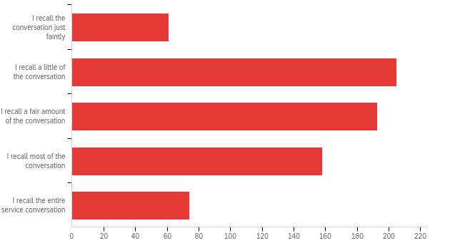

|  |  |  |  |  |  |  |  |
| --- | --- | --- | --- | --- | --- | --- | --- |
| # | Field | Minimum | Maximum | Mean | Std Deviation | Variance | Count |
| 1 | How well do you recall this service conversation? | 1.00 | 10.00 | 5.59 | 2.83 | 7.99 | 692 |

|  |  |  |  |
| --- | --- | --- | --- |
| # | Answer | % | Count |
| 2 | I recall the conversation just faintly | 8.83% | 61 |
| 3 | I recall a little of the conversation | 29.67% | 205 |
| 5 | I recall a fair amount of the conversation | 27.93% | 193 |
| 9 | I recall most of the conversation | 22.87% | 158 |
| 10 | I recall the entire service conversation | 10.71% | 74 |
|  | Total | 100% | 691 |

**QID28 - In this latest encounter with [QID71-ChoiceGroup-SelectedChoices] I tried to…**

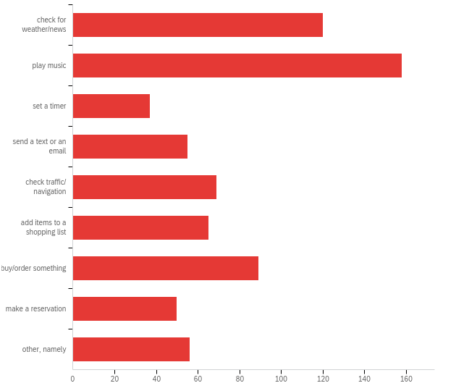

|  |  |  |  |  |  |  |  |
| --- | --- | --- | --- | --- | --- | --- | --- |
| # | Field | Minimum | Maximum | Mean | Std Deviation | Variance | Count |
| 1 | In this latest encounter with [QID71-ChoiceGroup-SelectedChoices] I tried to… - Selected Choice | 1.00 | 9.00 | 4.33 | 2.67 | 7.15 | 699 |

|  |  |  |  |
| --- | --- | --- | --- |
| # | Answer | % | Count |
| 1 | check for weather/news | 17.17% | 120 |
| 2 | play music | 22.60% | 158 |
| 3 | set a timer | 5.29% | 37 |
| 4 | send a text or an email | 7.87% | 55 |
| 5 | check traffic/ navigation | 9.87% | 69 |
| 6 | add items to a shopping list | 9.30% | 65 |
| 7 | buy/order something | 12.73% | 89 |
| 8 | make a reservation | 7.15% | 50 |
| 9 | other, namely | 8.01% | 56 |
|  | Total | 100% | 699 |

QID28_9_TEXT - other, namely

|  |
| --- |
| other, namely - Text |
| research paintings/artists |
| check to see what movies were playing and their times. |
| reminder |
| Inquiring about a nearest restaurant |
| find information on a person |
| finding information about various things, like facts |
| calculate the difference between donating plasma and doing HITs |
| I asked Alexa how she felt this evening. |
| check movies |
| check flight information |
| diagnose computer beep signals |
| See if a bait shop near my house was open on sunday |
| Check reminders and set a new one up |
| find a sports schedule |
| research a scientific term |
| What deals did Amazon have that day |
| Set a reminder |
| find out some nutritional information |
| checking to see if a restaurant was open and for how long |
| movie times |
| check proficiency |
| ask about the cast of a TV show I was watching |
| Asked for information regarding usage of a particular word |
| send a voice message |
| I was trying to look up a historical person and ask questions about them. |
| See if tickets for a show were available, and try to book the tickets and a hotel. |
| Research a specific topic |
| I tried to get it to play a story. |
| set reminders for myself at specific times |
| checking football information |
| Get information on the first actor to play James Bond |
| Look up song lyrics |
| Ask for recipes using a specific ingredient. |
| Get recommended products |
| find a nearby restaurant |
| set a reminder |
| check to see what time and what channel the PPV boxing match was going to be on on Saturday as well as the betting odds. |
| Check the shipping status of a package I was expecting from Amazon |
| choosing a restaurant |
| Look for apartments that were available for rent where my daughter needs to move to. |
| Play a game |
| Movie times and ticket prices |
| set up a smart light bulb |
| Find a movie on Tv |
| ask about a celebrity |
| recipe |
| Ask about a TV star. |
| find games for the kids |
| Set a reminder |
| Turn on lights in one room and turn off lights in another room. |
| Was trying to get her to play a specific book in my Audible library. She kept opening one book, but not the one I wanted for some reason. |
| learn information |
| Find the time for the football game |
| asking about a song |
| install new pc |

**QID30 - This latest encounter lasted roughly about …. minutes**

|  |
| --- |
| minutes |
| 30 |
| 30 |
| 4 |
| 20 |
| 120 |
| 30 |
| 3 |
| 2 |
| 3 |
| 5 |
| 5 |
| 50 |
| 30 |
| 2 |
| 60 |
| 3 |
| 30 |
| 60 |
| 30 |
| 3 |
| 10 |
| 3 |
| 6 |
| 30 |
| 5 |
| 35 |
| 5 |
| 60 |
| 60 |
| 40 |
| 2 |
| good |
| 5 |
| 30 |
| 5 |
| 45 |
| good |
| 60 |
| 5 |
| 6 |
| 40 |
| 2 |
| 2 |
| 15 |
| 15 |
| 10 |
| 30 |
| 5 |
| good |
| 10 |
| 2 |
| 2 |
| 20 |
| 3 |
| 7 |
| 5 |
| 5 |
| 50 |
| 2 |
| 45 |
| 50 |
| 5 |
| 30 |
| 30 |
| 2 |
| 20 |
| 25 |
| 5 |
| 20 |
| 5 |
| 20 |
| 10 |
| 4 |
| 5 |
| 45 |
| 30 |
| 20 |
| 20 |
| 4 |
| 55 |
| 1 |
| 1 |
| 15 |
| 60 |
| 1 |
| 5 |
| 45 |
| 2 |
| 2 |
| 15 |
| 10 |
| 7 |
| 30 |
| 5 |
| 30 |
| 30 |
| 60 |
| 1 |
| 30 |
| 5 |
| 20 |
| 15 |
| 2 |
| 5 |
| 10 |
| 3 |
| 10 |
| 120 |
| 2 |
| 30 |
| 5 |
| 30 |
| 3 |
| 10 |
| 5 |
| 30 |
| 3 |
| 35 |
| 0.5 |
| 5 |
| 50 |
| 1 |
| 10 |
| 10 |
| 1 |
| 2 |
| 3 |
| 2 |
| 2 |
| 10 |
| 3 |
| 4 |
| 5 |
| 60 |
| 2 |
| 20 |
| shopping |
| 7 |
| 8 |
| 5 |
| 2 |
| 3 |
| 6 |
| 25 |
| 10 |
| 2 |
| 15 |
| 20 |
| 30 |
| 1 |
| 20 |
| 50 |
| 15 |
| 8 |
| 60 |
| 1 |
| 2 |
| 10 |
| 2 |
| 20 |
| 2 |
| 5 |
| 1 |
| 2 |
| 15 |
| 09 |
| 30 |
| 30 |
| 30 |
| 5 |
| 30 |
| 2 |
| 4 |
| 5 |
| 2 |
| 56 |
| 5 |
| 5 |
| 1 |
| 30 |
| 30 |
| 30 |
| 2 |
| 4 |
| 55 |
| 5 |
| 5 |
| 15 |
| 5 |
| 50 |
| 45 |
| 3 |
| 4 |
| 1 |
| 2 |
| 2 |
| 6 |
| 30 |
| 5 |
| 5 |
| 15 |
| 5 |
| 50 |
| 6 |
| 15mins |
| 25 |
| About shopping |
| 20 |
| 1 |
| 2 |
| 3 |
| 7 |
| 5 |
| 20 |
| 10 |
| 60 |
| 30 |
| 30 |
| 40 |
| 20 |
| 15 |
| 2 |
| 30 |
| 35 |
| 5 |
| 10 |
| 2 |
| 30 |
| 1 |
| 60 |
| 15 |
| 10 |
| 30 |
| 5 |
| 10 |
| 30 |
| 2 |
| 15 |
| 5 |
| 20 |
| 10 |
| 3 |
| 10 |
| 5 |
| 5 |
| 30 |
| 3 |
| 4 |
| 6 |
| 5 |
| 3 |
| 45 |
| 10 |
| 50 |
| 10 |
| 10 |
| 1 |
| 2 |
| 5 |
| 10 |
| 5 |
| 3 |
| 2 |
| 1 |
| 2 |
| 4 |
| 2 |
| 10 |
| 1 |
| 10 |
| 15 |
| 2 |
| 20 |
| 2 |
| 5 |
| 2 |
| 3 |
| 5 |
| 1 |
| 1 |
| 30 |
| 5 |
| 2 |
| 2 |
| 5 |
| 15 |
| 1 |
| 1 |
| 3 |
| 3 |
| 30 |
| 4 minutes |
| 14 |
| 3 |
| 30 |
| 3 |
| 4 |
| 60 |
| 45 |
| 5 |
| 1 |
| 4 |
| 15 Minutes |
| 1 |
| 2 |
| 23 |
| 5 |
| 20 |
| 20 |
| 60 |
| 2 |
| 3 |
| 10 |
| 15 |
| 1 |
| 10 |
| 5 |
| 46 |
| 1 |
| 40 |
| 3 |
| 30 |
| 5 |
| 2 |
| 15 |
| 2 |
| 2 |
| 2 |
| 5 |
| 1 |
| 4 |
| 30 |
| 2 |
| 5 |
| 20 |
| 5 |
| 3 |
| 45 |
| 5 |
| 30 |
| 10 |
| 50 |
| 2 |
| 3 |
| 10 |
| 30 |
| 3 |
| 3 |
| 2 |
| 14 |
| 2 |
| 1 |
| 45 |
| 15 |
| 5 |
| 15 |
| 98 |
| 20 minute |
| 5 |
| 1 |
| 5 |
| 1 |
| 3 |
| 1 |
| 3 |
| 5 |
| 5 |
| 2 |
| 2 |
| 2 |
| 3 |
| 4 |
| 10 |
| 10 |
| 6 |
| 10 |
| 15 minutes |
| 2 |
| 4 |
| 2 |
| 3 |
| 2 |
| 4 |
| 3 |
| 10 |
| 15 |
| 10 |
| 3 |
| 50 |
| 3 |
| 2 |
| 10 |
| 2 |
| 15 |
| 3 |
| 2 |
| 30 |
| 5 |
| 5 |
| 6 |
| 5 |
| 2 |
| 2 |
| 5 |
| 10 |
| 4 |
| 2 |
| 15 |
| 2 |
| 1 |
| 5 |
| 2 |
| 6 |
| 3 |
| 2 |
| 5 |
| 15 |
| 3 |
| 4 |
| 3 |
| 2 |
| 23 |
| 2 |
| 2 |
| 15 minutes |
| 1 |
| 1 |
| 5 |
| 2 |
| 30 |
| 5 |
| 20 |
| 2 |
| 15 |
| 6 |
| 1.5 |
| 2 |
| 2 |
| 15 |
| 2 |
| 10 |
| 5 |
| 7 |
| 1 |
| 2 |
| 5 |
| 2 |
| 3 |
| 3 |
| 3 |
| 1 |
| 1 |
| 2 |
| 10 |
| 5 |
| 20 |
| 5 |
| 5 |
| 5 |
| 5 |
| 2 |
| 1 |
| 5 |
| 5 |
| 3 |
| 2 |
| 4 |
| 4 |
| 3 |
| 2 |
| 3 |
| 6 |
| 10 |
| 10 |
| 10 |
| 1 |
| 4 |
| 2 |
| 3 |
| 10 |
| 1 |
| 3 |
| 2 |
| 5 |
| 2 |
| 1 |
| 340 |
| 3 |
| 5 minutes |
| 2 |
| 60 |
| 4 |
| 3 |
| 10 |
| 5 |
| 3 |
| 2 |
| 1 |
| 10 |
| 2 |
| 53 |
| 2 |
| 4 |
| 5 |
| 5 |
| 2 |
| 5 |
| 5 |
| 2 |
| 5 |
| 1 |
| 5 |
| 10 |
| 5 |
| 1 |
| 2 |
| 8 |
| 4 |
| 2 |
| 15 |
| 10 |
| 15 |
| 4 |
| 5 |
| 4 |
| 5 |
| 5 |
| 2 |
| 3 |
| 3 |
| 3 |
| 2 |
| 2 |
| 2 |
| 1 |
| 2 |
| 2 |
| 4 |
| 3 |
| 4 |
| 5 |
| 4 |
| 1 |
| 8 |
| 2 |
| 4 |
| 10 |
| 2 |
| 5 |
| 2 |
| 5 |
| 2 |
| 2 |
| 2 |
| 2 |
| 340 |
| 4 |
| 5 |
| 5 |
| 7 |
| 4 |
| 1 |
| 10 |
| 3 |
| 25 minutes |
| 2 |
| 10 |
| 6 |
| 45 |
| 5 |
| 5 |
| 2 |
| 5 |
| 1 |
| 2 |
| 3 |
| 5 |
| 2 |
| 1 |
| 2 |
| 3 |
| 2 |
| 1 |
| 5 |
| 3 |
| 5 |
| 5-8 |
| 5 |
| 2 |
| 3 |
| 2 |
| 5 |
| 1 |
| 1 |
| 2 |
| 10 |
| 3 |
| 3 |
| 5 |
| 5 |
| 2 |
| 3 |
| 5 |
| 7 |
| 3 |
| 2 |
| 3 |
| 4 |
| 2 |
| 4 |
| 1 |
| 3 |
| 3 |
| 2 |
| 1 |
| 1 |
| 5 |
| 3 |
| 3 |
| 3 |
| 4 |
| 1 |
| 5 |
| 2 |
| 1 |
| 1 |
| 2 |
| 3 |
| 4 |
| 3 |
| 10 |
| 3 |
| 2 |
| 5 |
| 2 |
| 4 |
| 2 |
| 5 |
| 12 |
| 2 |
| 5 |
| 5 |
| 2 |
| 8 |
| 3 |
| 1 |
| 2 |
| 15 |
| four |
| 1 |
| 2 |
| 2 |
| 2 |
| 5 |
| 10 |
| 3 |
| 3 |
| 6 |
| 3 |
| 2 |
| 8 |
| 3 |
| 4 |
| 2 |
| 3 |
| 6 |
| 1 |
| 3 |
| 6 |
| 5 |
| 5 |
| 2 |
| 3 |
| 5 |
| 2 |
| 3 |
| 3 |
| 3 |
| 8 minutes |
| 2 |
| 5 |
| 2 |
| 6 |
| 5 |
| 3 |
| 5 |
| 2 |
| 9 |
| 9 |
| 9 |

**QID29 - While having my latest service encounter with the voice assistant [QID71-ChoiceGroup-SelectedChoices], I had the feeling that the voice assistant…**

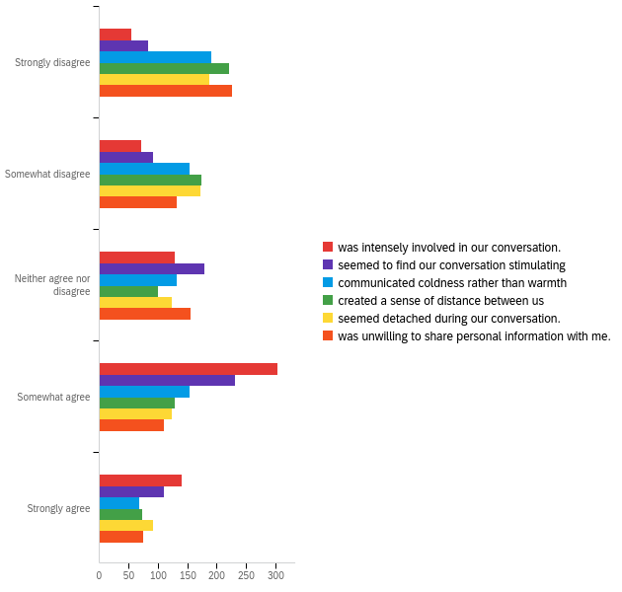

|  |  |  |  |  |  |  |  |
| --- | --- | --- | --- | --- | --- | --- | --- |
| # | Field | Minimum | Maximum | Mean | Std Deviation | Variance | Count |
| 1 | was intensely involved in our conversation. | 1.00 | 5.00 | 3.58 | 1.15 | 1.32 | 699 |
| 2 | seemed to find our conversation stimulating | 1.00 | 5.00 | 3.28 | 1.23 | 1.50 | 699 |
| 3 | communicated coldness rather than warmth | 1.00 | 5.00 | 2.65 | 1.34 | 1.80 | 699 |
| 4 | created a sense of distance between us | 1.00 | 5.00 | 2.51 | 1.37 | 1.88 | 699 |
| 5 | seemed detached during our conversation. | 1.00 | 5.00 | 2.66 | 1.38 | 1.90 | 699 |
| 6 | was unwilling to share personal information with me. | 1.00 | 5.00 | 2.53 | 1.36 | 1.86 | 699 |

|  |  |  |  |  |  |  |  |  |  |  |  |  |
| --- | --- | --- | --- | --- | --- | --- | --- | --- | --- | --- | --- | --- |
| # | Question | Strongly disagree |  | Somewhat disagree |  | Neither agree nor disagree |  | Somewhat agree |  | Strongly agree |  | Total |
| 1 | was intensely involved in our conversation. | 7.87% | 55 | 10.30% | 72 | 18.31% | 128 | 43.49% | 304 | 20.03% | 140 | 699 |
| 2 | seemed to find our conversation stimulating | 12.02% | 84 | 13.16% | 92 | 25.75% | 180 | 33.19% | 232 | 15.88% | 111 | 699 |
| 3 | communicated coldness rather than warmth | 27.32% | 191 | 22.03% | 154 | 18.88% | 132 | 22.03% | 154 | 9.73% | 68 | 699 |
| 4 | created a sense of distance between us | 31.76% | 222 | 25.04% | 175 | 14.45% | 101 | 18.31% | 128 | 10.44% | 73 | 699 |
| 5 | seemed detached during our conversation. | 26.75% | 187 | 24.61% | 172 | 17.74% | 124 | 17.74% | 124 | 13.16% | 92 | 699 |
| 6 | was unwilling to share personal information with me. | 32.47% | 227 | 18.88% | 132 | 22.17% | 155 | 15.74% | 110 | 10.73% | 75 | 699 |

**QID61 - While having my latest service encounter with the voice assistant [QID71-ChoiceGroup-SelectedChoices], I had the feeling that the voice assistant…**

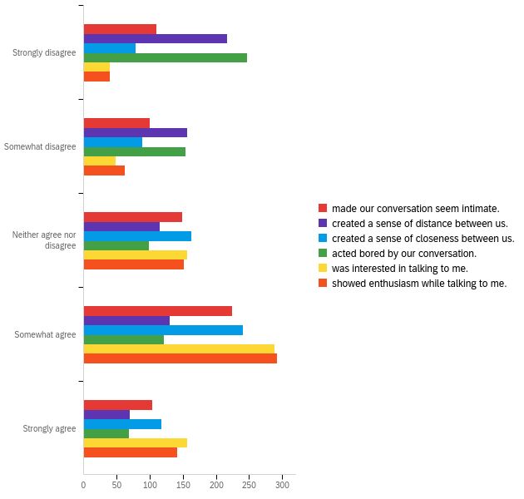

|  |  |  |  |  |  |  |  |
| --- | --- | --- | --- | --- | --- | --- | --- |
| # | Field | Minimum | Maximum | Mean | Std Deviation | Variance | Count |
| 1 | made our conversation seem intimate. | 1.00 | 5.00 | 3.16 | 1.30 | 1.69 | 688 |
| 2 | created a sense of distance between us. | 1.00 | 5.00 | 2.53 | 1.37 | 1.87 | 689 |
| 3 | created a sense of closeness between us. | 1.00 | 5.00 | 3.34 | 1.23 | 1.50 | 687 |
| 4 | acted bored by our conversation. | 1.00 | 5.00 | 2.44 | 1.38 | 1.91 | 690 |
| 5 | was interested in talking to me. | 1.00 | 5.00 | 3.69 | 1.08 | 1.16 | 689 |
| 6 | showed enthusiasm while talking to me. | 1.00 | 5.00 | 3.63 | 1.08 | 1.17 | 688 |

|  |  |  |  |  |  |  |  |  |  |  |  |  |
| --- | --- | --- | --- | --- | --- | --- | --- | --- | --- | --- | --- | --- |
| # | Question | Strongly disagree |  | Somewhat disagree |  | Neither agree nor disagree |  | Somewhat agree |  | Strongly agree |  | Total |
| 1 | made our conversation seem intimate. | 15.99% | 110 | 14.53% | 100 | 21.66% | 149 | 32.70% | 225 | 15.12% | 104 | 688 |
| 2 | created a sense of distance between us. | 31.49% | 217 | 22.79% | 157 | 16.69% | 115 | 18.87% | 130 | 10.16% | 70 | 689 |
| 3 | created a sense of closeness between us. | 11.35% | 78 | 12.81% | 88 | 23.73% | 163 | 35.08% | 241 | 17.03% | 117 | 687 |
| 4 | acted bored by our conversation. | 35.80% | 247 | 22.32% | 154 | 14.35% | 99 | 17.54% | 121 | 10.00% | 69 | 690 |
| 5 | was interested in talking to me. | 5.81% | 40 | 6.97% | 48 | 22.64% | 156 | 41.80% | 288 | 22.79% | 157 | 689 |
| 6 | showed enthusiasm while talking to me. | 5.81% | 40 | 9.01% | 62 | 22.09% | 152 | 42.44% | 292 | 20.64% | 142 | 688 |

**QID31 - While having my latest service encounter with the voice assistant [QID71-ChoiceGroup-SelectedChoices], I had the feeling that the voice assistant…**

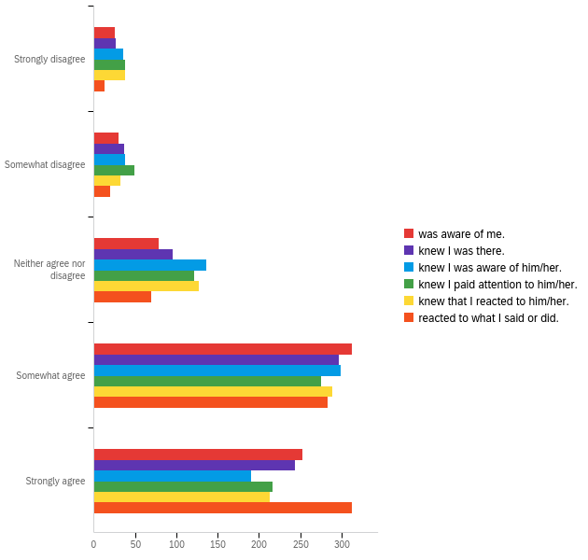

|  |  |  |  |  |  |  |  |
| --- | --- | --- | --- | --- | --- | --- | --- |
| # | Field | Minimum | Maximum | Mean | Std Deviation | Variance | Count |
| 1 | was aware of me. | 1.00 | 5.00 | 4.06 | 0.98 | 0.96 | 699 |
| 2 | knew I was there. | 1.00 | 5.00 | 3.99 | 1.02 | 1.03 | 699 |
| 3 | knew I was aware of him/her. | 1.00 | 5.00 | 3.81 | 1.05 | 1.11 | 699 |
| 4 | knew I paid attention to him/her. | 1.00 | 5.00 | 3.83 | 1.11 | 1.22 | 699 |
| 5 | knew that I reacted to him/her. | 1.00 | 5.00 | 3.87 | 1.07 | 1.14 | 699 |
| 6 | reacted to what I said or did. | 1.00 | 5.00 | 4.23 | 0.88 | 0.77 | 699 |

|  |  |  |  |  |  |  |  |  |  |  |  |  |
| --- | --- | --- | --- | --- | --- | --- | --- | --- | --- | --- | --- | --- |
| # | Question | Strongly disagree |  | Somewhat disagree |  | Neither agree nor disagree |  | Somewhat agree |  | Strongly agree |  | Total |
| 1 | was aware of me. | 3.58% | 25 | 4.29% | 30 | 11.16% | 78 | 44.78% | 313 | 36.19% | 253 | 699 |
| 2 | knew I was there. | 3.72% | 26 | 5.29% | 37 | 13.73% | 96 | 42.49% | 297 | 34.76% | 243 | 699 |
| 3 | knew I was aware of him/her. | 5.15% | 36 | 5.44% | 38 | 19.46% | 136 | 42.78% | 299 | 27.18% | 190 | 699 |
| 4 | knew I paid attention to him/her. | 5.44% | 38 | 7.01% | 49 | 17.31% | 121 | 39.34% | 275 | 30.90% | 216 | 699 |
| 5 | knew that I reacted to him/her. | 5.44% | 38 | 4.58% | 32 | 18.17% | 127 | 41.34% | 289 | 30.47% | 213 | 699 |
| 6 | reacted to what I said or did. | 1.86% | 13 | 2.86% | 20 | 10.01% | 70 | 40.49% | 283 | 44.78% | 313 | 699 |

**QID63 - In my latest service encounter with the voice assistant [QID71-ChoiceGroup-SelectedChoices], the voice assistant was…**

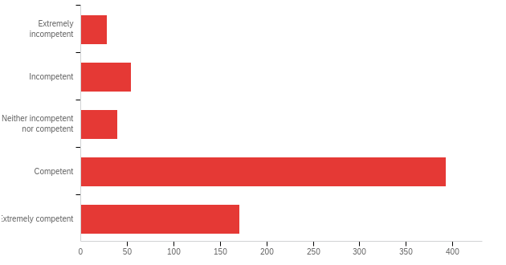

|  |  |  |  |  |  |  |  |
| --- | --- | --- | --- | --- | --- | --- | --- |
| # | Field | Minimum | Maximum | Mean | Std Deviation | Variance | Count |
| 1 | In my latest service encounter with the voice assistant [QID71-ChoiceGroup-SelectedChoices], the voice assistant was… | 1.00 | 5.00 | 3.91 | 0.99 | 0.98 | 685 |

|  |  |  |  |
| --- | --- | --- | --- |
| # | Answer | % | Count |
| 1 | Extremely incompetent | 4.09% | 28 |
| 2 | Incompetent | 7.88% | 54 |
| 3 | Neither incompetent nor competent | 5.69% | 39 |
| 4 | Competent | 57.37% | 393 |
| 5 | Extremely competent | 24.96% | 171 |
|  | Total | 100% | 685 |

**QID64 - In my latest service encounter with the voice assistant [QID71-ChoiceGroup-SelectedChoices], the voice assistant was…**

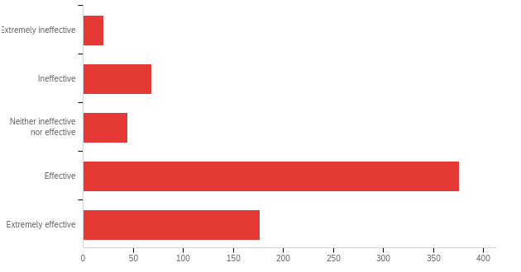

|  |  |  |  |  |  |  |  |
| --- | --- | --- | --- | --- | --- | --- | --- |
| # | Field | Minimum | Maximum | Mean | Std Deviation | Variance | Count |
| 1 | In my latest service encounter with the voice assistant [QID71-ChoiceGroup-SelectedChoices], the voice assistant was… | 1.00 | 5.00 | 3.91 | 0.99 | 0.97 | 685 |

|  |  |  |  |
| --- | --- | --- | --- |
| # | Answer | % | Count |
| 1 | Extremely ineffective | 2.92% | 20 |
| 2 | Ineffective | 9.93% | 68 |
| 3 | Neither ineffective nor effective | 6.42% | 44 |
| 4 | Effective | 54.89% | 376 |
| 5 | Extremely effective | 25.84% | 177 |
|  | Total | 100% | 685 |

**QID65 - In my latest service encounter with the voice assistant [QID71-ChoiceGroup-SelectedChoices], the voice assistant was…**

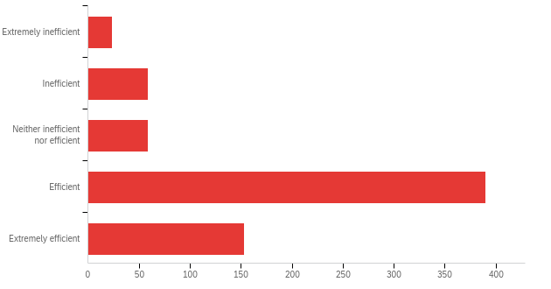

|  |  |  |  |  |  |  |  |
| --- | --- | --- | --- | --- | --- | --- | --- |
| # | Field | Minimum | Maximum | Mean | Std Deviation | Variance | Count |
| 1 | In my latest service encounter with the voice assistant [QID71-ChoiceGroup-SelectedChoices], the voice assistant was… | 1.00 | 5.00 | 3.86 | 0.97 | 0.95 | 685 |

|  |  |  |  |
| --- | --- | --- | --- |
| # | Answer | % | Count |
| 1 | Extremely inefficient | 3.50% | 24 |
| 2 | Inefficient | 8.61% | 59 |
| 3 | Neither inefficient nor efficient | 8.61% | 59 |
| 4 | Efficient | 56.93% | 390 |
| 5 | Extremely efficient | 22.34% | 153 |
|  | Total | 100% | 685 |

**QID66 - In my latest service encounter with the voice assistant [QID71-ChoiceGroup-SelectedChoices], the voice assistant was…**

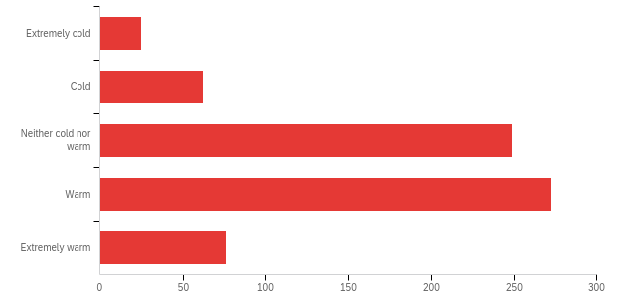

|  |  |  |  |  |  |  |  |
| --- | --- | --- | --- | --- | --- | --- | --- |
| # | Field | Minimum | Maximum | Mean | Std Deviation | Variance | Count |
| 1 | In my latest service encounter with the voice assistant [QID71-ChoiceGroup-SelectedChoices], the voice assistant was… | 1.00 | 5.00 | 3.46 | 0.93 | 0.87 | 685 |

|  |  |  |  |
| --- | --- | --- | --- |
| # | Answer | % | Count |
| 1 | Extremely cold | 3.65% | 25 |
| 2 | Cold | 9.05% | 62 |
| 3 | Neither cold nor warm | 36.35% | 249 |
| 4 | Warm | 39.85% | 273 |
| 5 | Extremely warm | 11.09% | 76 |
|  | Total | 100% | 685 |

**QID67 - In my latest service encounter with the voice assistant [QID71-ChoiceGroup-SelectedChoices], the voice assistant was…**

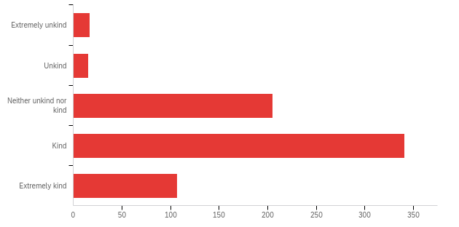

|  |  |  |  |  |  |  |  |
| --- | --- | --- | --- | --- | --- | --- | --- |
| # | Field | Minimum | Maximum | Mean | Std Deviation | Variance | Count |
| 1 | In my latest service encounter with the voice assistant [QID71-ChoiceGroup-SelectedChoices], the voice assistant was… | 1.00 | 5.00 | 3.74 | 0.84 | 0.70 | 685 |

|  |  |  |  |
| --- | --- | --- | --- |
| # | Answer | % | Count |
| 1 | Extremely unkind | 2.48% | 17 |
| 2 | Unkind | 2.19% | 15 |
| 3 | Neither unkind nor kind | 29.93% | 205 |
| 4 | Kind | 49.78% | 341 |
| 5 | Extremely kind | 15.62% | 107 |
|  | Total | 100% | 685 |

**QID68 - In my latest service encounter with the voice assistant [QID71-ChoiceGroup-SelectedChoices], the voice assistant was…**

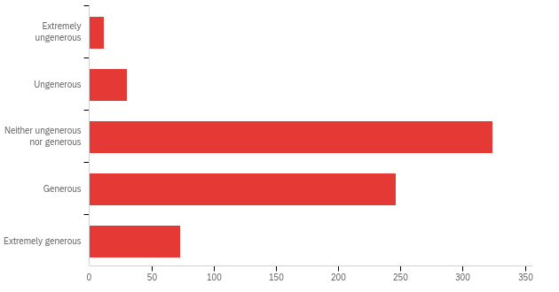

|  |  |  |  |  |  |  |  |
| --- | --- | --- | --- | --- | --- | --- | --- |
| # | Field | Minimum | Maximum | Mean | Std Deviation | Variance | Count |
| 1 | In my latest service encounter with the voice assistant [QID71-ChoiceGroup-SelectedChoices], the voice assistant was… | 1.00 | 5.00 | 3.49 | 0.81 | 0.66 | 685 |

|  |  |  |  |
| --- | --- | --- | --- |
| # | Answer | % | Count |
| 1 | Extremely ungenerous | 1.75% | 12 |
| 2 | Ungenerous | 4.38% | 30 |
| 3 | Neither ungenerous nor generous | 47.30% | 324 |
| 4 | Generous | 35.91% | 246 |
| 5 | Extremely generous | 10.66% | 73 |
|  | Total | 100% | 685 |

**QID34 - Let’s see if you’re still 100% involved. Could you please select red in this stop light?**

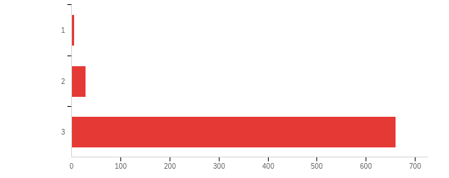

|  |  |  |  |  |  |  |  |
| --- | --- | --- | --- | --- | --- | --- | --- |
| # | Field | Minimum | Maximum | Mean | Std Deviation | Variance | Count |
| 1 | Let’s see if you’re still 100% involved. Could you please select red in this stop light? | 1.00 | 6.00 | 2.95 | 0.28 | 0.08 | 695 |

|  |  |  |  |
| --- | --- | --- | --- |
| # | Answer | % | Count |
| 1 | 1 | 0.72% | 5 |
| 2 | 2 | 4.03% | 28 |
| 3 | 3 | 95.24% | 661 |
|  | Total | 100% | 694 |

**QID37 - In my latest service encounter with the voice assistant [QID71-ChoiceGroup-SelectedChoices], I had the feeling that…**

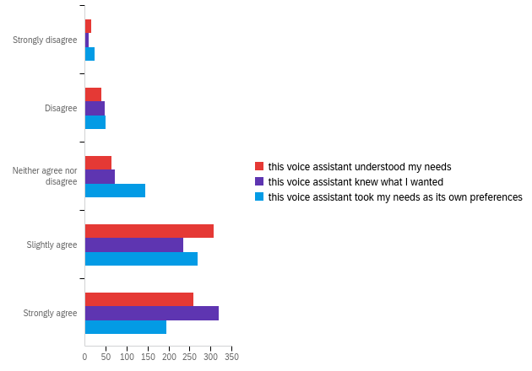

|  |  |  |  |  |  |  |  |
| --- | --- | --- | --- | --- | --- | --- | --- |
| # | Field | Minimum | Maximum | Mean | Std Deviation | Variance | Count |
| 1 | this voice assistant understood my needs | 1.00 | 9.00 | 8.01 | 1.35 | 1.83 | 687 |
| 2 | this voice assistant knew what I wanted | 1.00 | 9.00 | 8.08 | 1.32 | 1.75 | 687 |
| 3 | this voice assistant took my needs as its own preferences | 1.00 | 9.00 | 7.64 | 1.60 | 2.56 | 687 |

|  |  |  |  |  |  |  |  |  |  |  |  |  |
| --- | --- | --- | --- | --- | --- | --- | --- | --- | --- | --- | --- | --- |
| # | Question | Strongly disagree |  | Disagree |  | Neither agree nor disagree |  | Slightly agree |  | Strongly agree |  | Total |
| 1 | this voice assistant understood my needs | 2.19% | 15 | 5.83% | 40 | 9.33% | 64 | 44.90% | 308 | 37.76% | 259 | 686 |
| 2 | this voice assistant knew what I wanted | 1.47% | 10 | 6.89% | 47 | 10.56% | 72 | 34.31% | 234 | 46.77% | 319 | 682 |
| 3 | this voice assistant took my needs as its own preferences | 3.52% | 24 | 7.33% | 50 | 21.26% | 145 | 39.44% | 269 | 28.45% | 194 | 682 |

**QID38 - In this specific service encounter with the voice assistant [QID71-ChoiceGroup-SelectedChoices], I had the feeling that…**

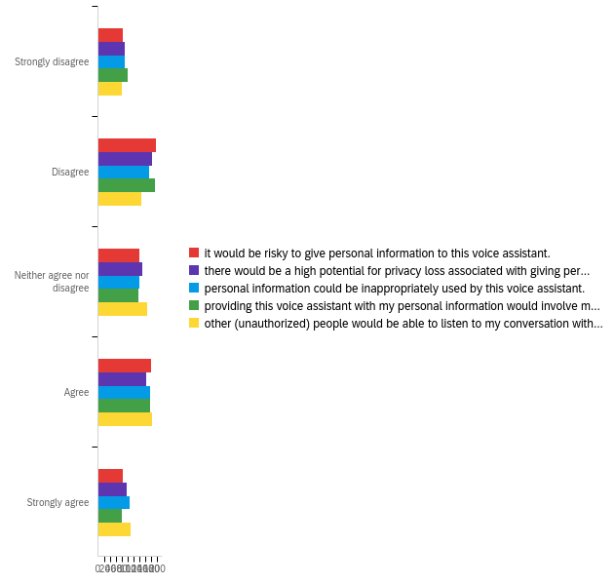

|  |  |  |  |  |  |  |  |
| --- | --- | --- | --- | --- | --- | --- | --- |
| # | Field | Minimum | Maximum | Mean | Std Deviation | Variance | Count |
| 1 | it would be risky to give personal information to this voice assistant. | 2.00 | 10.00 | 7.93 | 1.32 | 1.74 | 687 |
| 2 | there would be a high potential for privacy loss associated with giving personal information to this voice assistant. | 1.00 | 10.00 | 7.96 | 1.34 | 1.80 | 687 |
| 3 | personal information could be inappropriately used by this voice assistant. | 1.00 | 10.00 | 8.02 | 1.36 | 1.85 | 687 |
| 4 | providing this voice assistant with my personal information would involve many unexpected problems. | 2.00 | 10.00 | 7.89 | 1.33 | 1.76 | 687 |
| 5 | other (unauthorized) people would be able to listen to my conversation with my voice assistant. | 2.00 | 10.00 | 8.11 | 1.31 | 1.73 | 687 |

|  |  |  |  |  |  |  |  |  |  |  |  |  |
| --- | --- | --- | --- | --- | --- | --- | --- | --- | --- | --- | --- | --- |
| # | Question | Strongly disagree |  | Disagree |  | Neither agree nor disagree |  | Agree |  | Strongly agree |  | Total |
| 1 | it would be risky to give personal information to this voice assistant. | 12.46% | 85 | 28.89% | 197 | 20.23% | 138 | 26.10% | 178 | 12.32% | 84 | 682 |
| 2 | there would be a high potential for privacy loss associated with giving personal information to this voice assistant. | 13.34% | 91 | 26.54% | 181 | 21.85% | 149 | 23.90% | 163 | 14.37% | 98 | 682 |
| 3 | personal information could be inappropriately used by this voice assistant. | 13.05% | 89 | 25.07% | 171 | 20.38% | 139 | 25.95% | 177 | 15.54% | 106 | 682 |
| 4 | providing this voice assistant with my personal information would involve many unexpected problems. | 14.52% | 99 | 28.01% | 191 | 19.94% | 136 | 25.66% | 175 | 11.88% | 81 | 682 |
| 5 | other (unauthorized) people would be able to listen to my conversation with my voice assistant. | 11.58% | 79 | 21.41% | 146 | 24.34% | 166 | 26.54% | 181 | 16.13% | 110 | 682 |

**QID39 - Please think once more about your latest encounter. How satisfied were you with….**

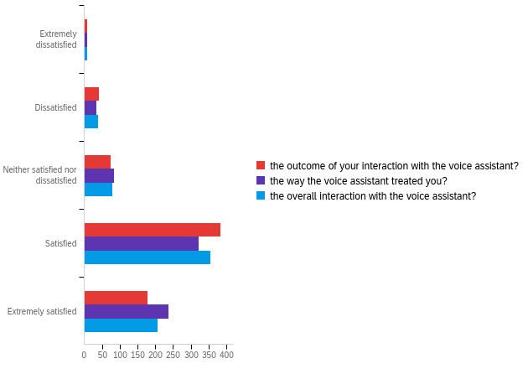

|  |  |  |  |  |  |  |  |
| --- | --- | --- | --- | --- | --- | --- | --- |
| # | Field | Minimum | Maximum | Mean | Std Deviation | Variance | Count |
| 1 | the outcome of your interaction with the voice assistant? | 1.00 | 5.00 | 3.99 | 0.85 | 0.73 | 687 |
| 2 | the way the voice assistant treated you? | 1.00 | 5.00 | 4.09 | 0.88 | 0.78 | 687 |
| 3 | the overall interaction with the voice assistant? | 1.00 | 5.00 | 4.03 | 0.87 | 0.75 | 687 |

|  |  |  |  |  |  |  |  |  |  |  |  |  |
| --- | --- | --- | --- | --- | --- | --- | --- | --- | --- | --- | --- | --- |
| # | Question | Extremely dissatisfied |  | Dissatisfied |  | Neither satisfied nor dissatisfied |  | Satisfied |  | Extremely satisfied |  | Total |
| 1 | the outcome of your interaction with the voice assistant? | 1.31% | 9 | 5.97% | 41 | 10.92% | 75 | 55.75% | 383 | 26.06% | 179 | 687 |
| 2 | the way the voice assistant treated you? | 1.31% | 9 | 4.95% | 34 | 12.08% | 83 | 47.02% | 323 | 34.64% | 238 | 687 |
| 3 | the overall interaction with the voice assistant? | 1.16% | 8 | 5.82% | 40 | 11.35% | 78 | 51.67% | 355 | 29.99% | 206 | 687 |

**QID42 - What is your gender?**

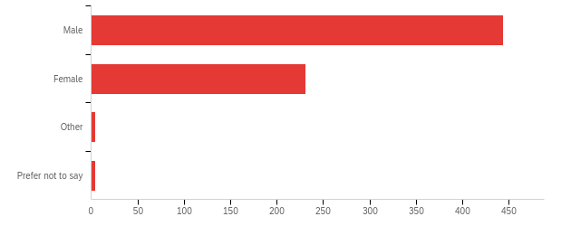

|  |  |  |  |  |  |  |  |
| --- | --- | --- | --- | --- | --- | --- | --- |
| # | Field | Minimum | Maximum | Mean | Std Deviation | Variance | Count |
| 1 | What is your gender? | 1.00 | 4.00 | 1.37 | 0.53 | 0.28 | 683 |

|  |  |  |  |
| --- | --- | --- | --- |
| # | Answer | % | Count |
| 1 | Male | 65.01% | 444 |
| 2 | Female | 33.82% | 231 |
| 3 | Other | 0.59% | 4 |
| 4 | Prefer not to say | 0.59% | 4 |
|  | Total | 100% | 683 |

**QID43 - What is your age (in years)?**

|  |
| --- |
| What is your age (in years)? |
| 32 |
| 25 |
| 26 |
| 33 |
| 28 |
| 32 |
| 25 |
| 36 |
| 30 |
| 32 |
| 36 |
| 41 |
| 30 |
| 34 |
| 35 |
| 58 |
| 34 |
| 30 |
| 30 |
| 28 |
| 33 |
| 34 |
| 30 |
| 23 |
| 30 |
| 60 |
| 32 |
| 25 |
| 36 |
| 24 |
| 32 |
| 32 |
| 28 |
| 30 |
| 22 |
| 30 |
| 69 |
| 29 |
| 32 |
| 33 |
| 26 |
| 28 |
| 41 |
| 32 |
| 30 |
| 41 |
| 33 |
| 41 |
| 35 |
| 26 |
| 32 |
| 30 |
| 35 |
| 69 |
| 30 |
| 25 |
| 26 |
| 32 |
| 30 |
| 31 |
| 30 |
| 30 |
| 32 |
| 30 |
| 35 |
| 27 |
| 47 |
| 23 |
| 29 |
| 27 |
| 30 |
| 30 |
| 30 |
| 37 |
| 51 |
| 48 |
| 46 |
| 29 |
| 23 |
| 58 |
| 40 |
| 34 |
| 23 |
| 30 |
| 41 |
| 30 |
| 21 |
| 30 |
| 32 |
| 32 |
| 25 |
| 36 |
| 44 |
| 30 |
| 34 |
| 45 |
| 30 |
| 49 |
| 32 |
| 46 |
| 33 |
| 30 |
| 57 |
| 23 |
| 30 |
| 32 |
| 30 |
| 50 |
| 54 |
| 36 |
| 29 |
| 36 |
| 35 |
| 51 |
| 61 |
| 32 |
| 25 |
| 58 |
| 32 |
| 33 |
| 26 |
| 35 |
| 25 |
| 28 |
| 34 |
| 23 |
| 25 |
| 30 |
| 45 |
| 25 |
| 35 |
| 47 |
| 57 |
| 37 |
| 44 |
| 35 |
| 44 |
| 27 |
| 38 |
| 45 |
| 29 |
| 45 |
| 36 |
| 30 |
| 38 |
| 42 |
| 28 |
| 28 |
| 30 |
| 50 |
| 28 |
| 24 |
| 25 |
| 36 |
| 35 |
| 30 |
| 32 |
| 33 |
| 35 |
| 30 |
| 30 |
| 32 |
| 31 |
| 29 |
| 24 |
| 30 |
| 34 |
| 45 |
| 38 |
| 37 |
| 38 |
| 32 |
| 38 |
| 25 |
| 32 |
| 30 |
| 30 |
| 33 |
| 30 |
| 35 |
| 62 |
| 58 |
| 28 |
| 60 |
| 39 |
| 28 |
| 30 |
| 31 |
| 30 |
| 34 |
| 36 |
| 30 |
| 33 |
| 60 |
| 35 |
| 28 |
| 32 |
| 32 |
| 60 |
| 57 |
| 53 |
| 49 |
| 25 |
| 25 |
| 29 |
| 29 |
| 28 |
| 43 |
| 32 |
| 58 |
| 32 |
| 34 |
| 33 |
| 30 |
| 30 |
| 60 |
| 28 |
| 30 |
| 35 |
| 26 |
| 44 |
| 47 |
| 46 |
| 34 |
| 30 |
| 34 |
| 37 |
| 35 |
| 35 |
| 33 |
| 34 |
| 29 |
| 34 |
| 39 |
| 28 |
| 33 |
| 34 |
| 70 |
| 28 |
| 44 |
| 30 |
| 32 |
| 52 |
| 23 |
| 33 |
| 34 |
| 47 |
| 38 |
| 28 |
| 25 |
| 25 |
| 24 |
| 27 |
| 32 |
| 31 |
| 43 |
| 37 |
| 35 |
| 39 |
| 46 |
| 39 |
| 34 |
| 4 |
| 54 |
| 26 |
| 25 |
| 28 |
| 41 |
| 50 |
| 60 |
| 25 |
| 52 |
| 37 |
| 39 |
| 32 |
| 59 |
| 32 |
| 22 |
| 34 |
| 37 |
| 34 |
| 30 |
| 57 |
| 24 |
| 44 |
| 26 |
| 25 |
| 46 |
| 60 |
| 53 |
| 22 |
| 45 |
| 23 |
| 32 |
| 49 |
| 26 |
| 28 |
| 22 |
| 34 |
| 37 |
| 31 |
| 37 |
| 61 |
| 32 |
| 30 |
| 37 |
| 54 |
| 30 |
| 28 |
| 29 |
| 30 |
| 31 |
| 30 |
| 36 |
| 30 |
| 41 |
| 40 |
| 44 |
| 25 |
| 36 |
| 29 |
| 34 |
| 22 |
| 38 |
| 27 |
| 29 |
| 28 |
| 28 |
| 28 |
| 35 |
| 33 |
| 47 |
| 47 |
| 30 |
| 30 |
| 64 |
| 25 |
| 30 |
| 30 |
| 27 |
| 25 |
| 40 |
| 27 |
| 43 |
| 32 |
| 52 |
| 33 |
| 25 |
| 28 |
| 30 |
| 50 |
| 50 |
| 50 |
| 23 |
| 33 |
| 25 |
| 36 |
| 45 |
| 33 |
| 54 |
| 44 |
| 27 |
| 26 |
| 26 |
| 29 |
| 66 |
| 26 |
| 59 |
| 45 |
| 28 |
| 24 |
| 33 |
| 36 |
| 52 |
| 48 |
| 28 |
| 34 |
| 28 |
| 29 |
| 28 |
| 29 |
| 42 |
| 29 |
| 25 |
| 51 |
| 27 |
| 37 |
| 36 |
| 28 |
| 25 |
| 30 |
| 34 |
| 45 |
| 30 |
| 45 |
| 70 |
| 36 |
| 40 |
| 28 |
| 33 |
| 45 |
| 40 |
| 30 |
| 33 |
| 67 |
| 39 |
| 35 |
| 31 |
| 36 |
| 47 |
| 28 |
| 37 |
| 31 |
| 53 |
| 41 |
| 34 |
| 32 |
| 27 |
| 25 |
| 21 |
| 23 |
| 29 |
| 62 |
| 28 |
| 37 |
| 28 |
| 59 |
| 25 |
| 27 |
| 31 |
| 28 |
| 37 |
| 54 |
| 53 |
| 33 |
| 24 |
| 37 |
| 28 |
| 52 |
| 38 |
| 51 |
| 23 |
| 35 |
| 38 |
| 52 |
| 61 |
| 38 |
| 30 |
| 52 |
| 25 |
| 30 |
| 36 |
| 31 |
| 36 |
| 53 |
| 40 |
| 38 |
| 33 |
| 32 |
| 40 |
| 53 |
| 36 |
| 26 |
| 37 |
| 32 |
| 40 |
| 42 |
| 66 |
| 47 |
| 45 |
| 55 |
| 36 |
| 42 |
| 29 |
| 31 |
| 29 |
| 38 |
| 44 |
| 32 |
| 43 |
| 55 |
| 25 |
| 41 |
| 39 |
| 32 |
| 33 |
| 32 |
| 76 |
| 30 |
| 38 |
| 32 |
| 35 |
| 34 |
| 29 |
| 36 |
| 31 |
| 40 |
| 30 |
| 26 |
| 39 |
| 67 |
| 32 |
| 40 |
| 43 |
| 74 |
| 45 |
| 56 |
| 28 |
| 35 |
| 37 |
| 49 |
| 30 |
| 39 |
| 42 |
| 39 |
| 36 |
| 50 |
| 58 |
| 33 |
| 39 |
| 40 |
| 35 |
| 27 |
| 57 |
| 39 |
| 43 |
| 38 |
| 52 |
| 41 |
| 33 |
| 46 |
| 39 |
| 33 |
| 34 |
| 38 |
| 32 |
| 45 |
| 36 |
| 38 |
| 47 |
| 52 |
| 43 |
| 34 |
| 27 |
| 45 |
| 32 |
| 33 |
| 29 |
| 31 |
| 32 |
| 28 |
| 44 |
| 35 |
| 24 |
| 43 |
| 28 |
| 34 |
| 35 |
| 34 |
| 45 |
| 31 |
| 38 |
| 22 |
| 40 |
| 45 |
| 25 |
| 49 |
| 36 |
| 33 |
| 28 |
| 37 |
| 28 |
| 39 |
| 59 |
| 36 |
| 37 |
| 39 |
| 50 |
| 40 |
| 29 |
| 43 |
| 39 |
| 29 |
| 37 |
| 59 |
| 28 |
| 34 |
| 25 |
| 42 |
| 52 |
| 38 |
| 37 |
| 34 |
| 40 |
| 39 |
| 42 |
| 39 |
| 39 |
| 32 |
| 42 |
| 41 |
| 28 |
| 23 |
| 35 |
| 42 |
| 34 |
| 32 |
| 24 |
| 46 |
| 37 |
| 38 |
| 33 |
| 41 |
| 45 |
| 29 |
| 37 |
| 28 |
| 31 |
| 48 |
| 34 |
| 33 |
| 40 |
| 51 |
| 36 |
| 34 |
| 48 |
| 30 |
| 60 |
| 58 |
| 36 |
| 25 |
| 39 |
| 55 |
| 34 |
| 59 |
| 59 |
| 29 |
| 30 |
| 32 |
| 32 |
| 49 |
| 29 |
| 49 |
| 45 |
| 55 |
| 46 |
| 33 |
| 47 |
| 50 |
| 29 |
| 54 |
| 38 |
| 8 |
| 32 |
| 31 |
| 40 |
| 37 |
| 54 |
| 57 |
| 48 |
| 65 |
| 32 |
| 68 |
| 36 |
| 41 |
| 68 |
| 41 |
| 56 |
| 33 |
| 64 |
| 48 |
| 54 |
| 49 |
| 9999 |
| 8 |
| 8 |
| 56 |
| 75 |
| 10 |

**QID44 - In which country do you live?**

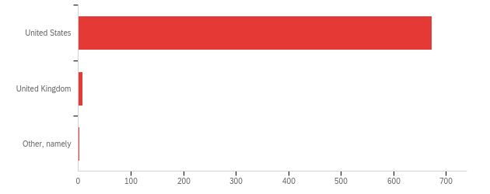

|  |  |  |  |  |  |  |  |
| --- | --- | --- | --- | --- | --- | --- | --- |
| # | Field | Minimum | Maximum | Mean | Std Deviation | Variance | Count |
| 1 | In which country do you live? - Selected Choice | 1.00 | 3.00 | 1.02 | 0.15 | 0.02 | 683 |

|  |  |  |  |
| --- | --- | --- | --- |
| # | Answer | % | Count |
| 1 | United States | 98.54% | 673 |
| 2 | United Kingdom | 1.17% | 8 |
| 3 | Other, namely | 0.29% | 2 |
|  | Total | 100% | 683 |

QID44_3_TEXT - Other, namely

|  |
| --- |
| Other, namely - Text |
| NL |
| nl |

**QID45 - What is the highest level of education that you have completed so far?**

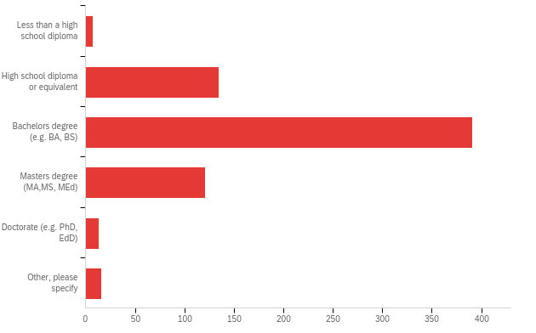

|  |  |  |  |  |  |  |  |
| --- | --- | --- | --- | --- | --- | --- | --- |
| # | Field | Minimum | Maximum | Mean | Std Deviation | Variance | Count |
| 1 | What is the highest level of education that you have completed so far? - Selected Choice | 1.00 | 6.00 | 3.07 | 0.84 | 0.70 | 683 |

|  |  |  |  |
| --- | --- | --- | --- |
| # | Answer | % | Count |
| 1 | Less than a high school diploma | 1.02% | 7 |
| 2 | High school diploma or equivalent | 19.77% | 135 |
| 3 | Bachelors degree (e.g. BA, BS) | 57.25% | 391 |
| 4 | Masters degree (MA,MS, MEd) | 17.72% | 121 |
| 5 | Doctorate (e.g. PhD, EdD) | 1.90% | 13 |
| 6 | Other, please specify | 2.34% | 16 |
|  | Total | 100% | 683 |

QID45_6_TEXT - Other, please specify

|  |
| --- |
| Other, please specify - Text |
| Associate degree |
| some college |
| some college no degree |
| Associates degree |
| some college |
| Associates Degree |
| AA |
| associates degree |
| Associate's Degree |
| associates |
| jd |
| Associate's Degree |
| some college no degree |
| Associates Degree |
| AA |
| Associate's Degree |

**QID46 - What is your current employment status?**

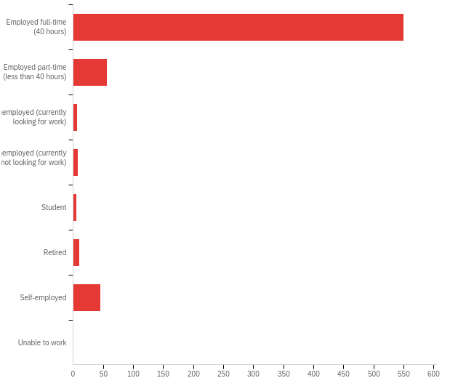

|  |  |  |  |  |  |  |  |
| --- | --- | --- | --- | --- | --- | --- | --- |
| # | Field | Minimum | Maximum | Mean | Std Deviation | Variance | Count |
| 1 | What is your current employment status? | 1.00 | 8.00 | 1.65 | 1.66 | 2.75 | 683 |

|  |  |  |  |
| --- | --- | --- | --- |
| # | Answer | % | Count |
| 1 | Employed full-time (40 hours) | 80.53% | 550 |
| 2 | Employed part-time (less than 40 hours) | 8.20% | 56 |
| 3 | Unemployed (currently looking for work) | 1.02% | 7 |
| 4 | Unemployed (currently not looking for work) | 1.17% | 8 |
| 5 | Student | 0.88% | 6 |
| 6 | Retired | 1.46% | 10 |
| 7 | Self-employed | 6.59% | 45 |
| 8 | Unable to work | 0.15% | 1 |
|  | Total | 100% | 683 |

**QID47 - Please indicate your marital status:**

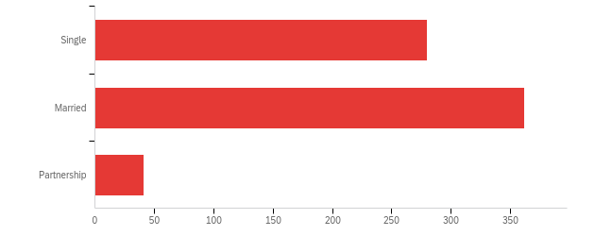

|  |  |  |  |  |  |  |  |
| --- | --- | --- | --- | --- | --- | --- | --- |
| # | Field | Minimum | Maximum | Mean | Std Deviation | Variance | Count |
| 1 | Please indicate your marital status: | 1.00 | 3.00 | 1.65 | 0.59 | 0.35 | 683 |

|  |  |  |  |
| --- | --- | --- | --- |
| # | Answer | % | Count |
| 1 | Single | 41.00% | 280 |
| 2 | Married | 53.00% | 362 |
| 3 | Partnership | 6.00% | 41 |
|  | Total | 100% | 683 |

**QID48 - What is your gross annual household income?**

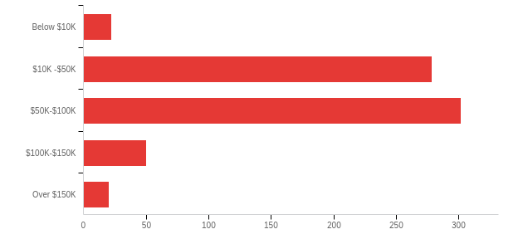

|  |  |  |  |  |  |  |  |
| --- | --- | --- | --- | --- | --- | --- | --- |
| # | Field | Minimum | Maximum | Mean | Std Deviation | Variance | Count |
| 1 | What is your gross annual household income? | 1.00 | 5.00 | 2.65 | 0.79 | 0.62 | 673 |

|  |  |  |  |
| --- | --- | --- | --- |
| # | Answer | % | Count |
| 1 | Below $10K | 3.27% | 22 |
| 2 | $10K -$50K | 41.46% | 279 |
| 3 | $50K-$100K | 44.87% | 302 |
| 4 | $100K-$150K | 7.43% | 50 |
| 5 | Over $150K | 2.97% | 20 |
|  | Total | 100% | 673 |

**QID49 - What is your gross annual household income?**

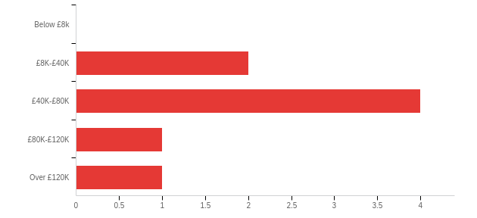

|  |  |  |  |  |  |  |  |
| --- | --- | --- | --- | --- | --- | --- | --- |
| # | Field | Minimum | Maximum | Mean | Std Deviation | Variance | Count |
| 1 | What is your gross annual household income? | 2.00 | 5.00 | 3.13 | 0.93 | 0.86 | 8 |

|  |  |  |  |
| --- | --- | --- | --- |
| # | Answer | % | Count |
| 1 | Below £8k | 0.00% | 0 |
| 2 | £8K-£40K | 25.00% | 2 |
| 3 | £40K-£80K | 50.00% | 4 |
| 4 | £80K-£120K | 12.50% | 1 |
| 5 | Over £120K | 12.50% | 1 |
|  | Total | 100% | 8 |

**QID40 - You reached the end of this survey. Tanks so much for supporting this research! If you have any questions, praise or criticism to share, please use the text box below.**

|  |
| --- |
| You reached the end of this survey. Tanks so much for supporting this research! If you have any questions, praise or criticism to share, please use the text box below. |
| None, thank you! |
| tanks |
| I'm satisfied with this survey |
| NO |
| good |
| good |
| do nothing |
| None |
| NO |
| NONE |
| Good |
| user scarification survey |
| nothing problem very easy work |
| Nothing else to add at this time. |
| good and use full survey |
| n/a |
| That is good criticism to share |
| very good |
| no |
| Very like survey. |
| none, thanks |
| good |
| no |
| its very good survey. |
| All good |
| good |
| N/A |
| this is an impressive survey |
| no |
| no |
| good |
| na |
| the survey is vary nice and good questing |
| good |
| user satiation survey |
| None |
| thank you! |
| no |
| very good |
| satisfactory |
| Great task |
| No, thank you. |
| good |
| any latest mobile have an a amazon? |
| none |
| NA |
| I am to happy sharing my experience |
| N0 |
| None |
| good |
| good |
| good |
| none. thank you. |
| no |
| good |
| I love seeing survey about our interactions with modern tech. |
| no |
| Such a nice survey, I would like this survey. |
| n/a |
| good |
| nice survey |
| good |
| Is awesome survey |
| good |
| very good survey |
| none |
| thanks! |
| lol |
| NA |
| good |
| good |
| good survey |
| Thank you for the cute emojis! |
| no |
| thanks, easy survey |
| thank you |
| no |
| good |
| none |
| Everything worked well. |
| good |
| None |
| No comments |
| None |
| GOOD |
| n/a |
| good |
| good |
| very interesting survey |
| good |
| good |
| I did not run into any problems or glitches in this study. Happy To Participate. |
| Good |
| The questions were clear and easy to understand. |
| NA |
| good |
| I have no feedback. |
| good |
| None |
| Thank you! |
| Good survey |
| it is very interesting survey to do |
| Thanks for the survey |
| good |
| good |
| academic suvey |
| GOOD |
| good |
| Thanks! |
| i love the survey |
| No comment |
| nice |
| NO |
| tHANKS |
| Very interesting |
| n/a |
| none |
| good experience |
| nothing else |
| nice survery |
| None. |
| I found this survey very comprehensive and easy to participate in. |
| There is no question, this survey is very interesting. |
| none |
| None thank you. |
| I enjoyed this survey, it made me realize how useful my assistant is to me |
| GOOD |
| it was an awesome survey |
| It has been interesting |
| nothing |
| good |
| no questions. |
| voice assistant are great invention |
| it is a nice survey, because i enjoy using my google assistant service a lot. |
| None |
| none at this time |
| excellent |
| no |
| no |
| Unique study! |
| Thank you |
| Good |
| very nice survey. |
| none |
| some places very critically |
| good |
| no |
| Good |
| Good |
| thanks |
| na |
| No |
| No thank you |
| very good survey and very useful |
| N/A |
| No |
| n/a |
| An impressive study |
| none |
| good like it survey |
| no |
| NONE |
| good |
| None, please. |
| very good supporting this survey |
| good |
| none |
| Very well designed survey. The pages went by at a fair pace and I liked being told when I was already 60% through. |
| N/A |
| no thanks |
| good |
| none |
| none |
| Very useful and interesting study |
| WELL DONE |
| nothing |
| N/A |
| none |
| good study |
| nones |
| NO QUESTIONS |
| None |
| good |
| good survey |
| na |
| none |
| nope! |
| No |
| I love taco nom nom nom |
| Thanks for the opportunity. |
| none |
| very nice survey |
| I'm glad this type of study is being done because assistants still need a lot of updates to be extremely useful. They are useful for very basic things and it's more important how you word your questions than anything else. |
| none |
| nothing |
| Great Study, hope to do more in the future. |
| good |
| n/a |
| this survey is very easy |
| good |
| Good |
| No |
| No there are no questions |
| none |
| I hope I didn't miss any attention checks other than the stoplight one, thank you for letting me take this! |
| nice |
| I usually do trivia with Alexa. I ask her the temperature or time several times throughout the day. Thank you for letting me participate. Have a spectacular day, and stay safe! |
| i like google assistant. |
| good |
| I like my Alexa a lot. Almost using it everyday. Her voice is so warm. |
| no |
| Nice Survey |
| nothing |
| Nothing |
| nice |
| none |
| good |
| very interesting survey |
| n/a |
| Nice |
| None |
| Nothing |
| Nothing |
| nothing |
| Good |
| None |
| ACADEMIC SURVEY |
| No comments. |
| Nothing to add. |
| good |
| none at all |
| thanks i enjoyed doing this |
| This was an enjoyable study! |
| Nice task |
| good survey |
| Good |
| good survey thanks |
| no comments |
| n/a |
| Informative. |
| No additional comments. |
| none |
| excellent |
| very nice |
| Thank you. |
| this is good |
| N/A |
| good survey |
| NO |
| No |
| interesting survey |
| n/a |
| none |
| No thanks |
| no question |
| n/a |
| Had no questions or issues. |
| none |
| None |
| thank you |
| none |
| eassy and usefuel servey |
| none |
| Haha, it was fun doing the survey and giving my experience with Siri. |
| nothing |
| n/a |
| no |
| Thank you |
| good |
| no |
| . |
| NO |
| thank you |
| none |
| good |
| good |
| N/A |
| thank you! |
| N/A |
| Research. and. the. Relevance. of. Science. The scientific investigation of Antarctica, but that is no longe |
| Great Survey |
| None |
| n/a |
| none |
| nothing |
| Great study |
| none |
| Interesting questions. I think it was helpful to read through |
| i like very much |
| It was a cool survey when it had the smiley face and saying 60% done. I wish other surveys had that. |
| nice clear layout |
| good |
| good |
| no questions |
| NA |
| clear study |
| Great survey! |
| No |
| None |
| good |
| Good and helpful. |
| n/a |
| very nice to use this |
| na |
| thanks for the pay. |
| none |
| good study |
| it is creative idea survey |
| None |
| fun study |
| none |
| good |
| THANKS! |
| Good and Nice. |
| thanks for a well laid out survey |
| nice |
| NO COMMENTS. THANK YOU FOR A CONCISE QUICK SURVEY. |
| n/a |
| nie |
| none |
| ty |
| no comments |
| none |
| NA |
| n/a |
| n/a |
| everything was clear |
| Thank you!! |
| no |
| I like the survey design and it was really clear. |
| None |
| good |
| ok |
| NO |
| GOOD |
| none |
| None |
| Thanks! |
| NA |
| nothing |
| n/a |
| N/A |
| Everything was fine, thanks! |
| no |
| I had no issues at all, thank you! |
| no |
| nice |
| Thanks |
| I enjoyed the study |
| no |
| - |
| - |
| n/a |
| None |
| none |
| TY! :) |
| N/A |
| Good survey design |
| No |
| Interesting project. Thanks |
| No. |
| none |
| na |
| Thank you! |
| Very nice study ! |
| Good |
| none , it worked fine for me |
| none |
| i love google voice assistant |
| None |
| n/a |
| I have no questions or anything else to share. |
| none |
| None |
| it was great idea |
| No questions, praise or criticism. |
| Thanks, and I hope your research bears fruit! |
| no |
| good survey |
| great survey |
| none, thanks. |
| very interesting |
| none |
| Thank you |
| None |
| Nothing to share! |
| decently paid survey for the time involved, good job |
| thank you, guys! ☺ |
| YOU SPELLED THANKS AS ''TANKS'' YOU SHOULD CORRECT THAT |
| none |
| Thank you. |
| None |
| It was set up well |
| Thanks for the survey! |
| I found voice assistants off putting initially, but now I am more comfortable using it on my smartphone. |
| Thank you! |
| none |
| The assistant uses voice queries and a natural-language user interface |
| n/a |
| no problems |
| cool beans |
| Thanks for the HIT! |
| n/a. Happy holidays to you all! |
| nill |
| Good survey |
| fun survey |
| 20 minute timer made me feel rushed |
| N/A |
| none |
| good |
| the final question about satisfaction with the interaction had an error in the likert scale. both "satisfied" and "extremely satisfied" were repeated twice. there was no way to express dissatisfaction. |
| none |
| Just noticed that in the question above, "thanks" is spelled as "tanks". Thanks for the opportunity to participate and good luck with your research! I enjoyed the clarity and crispness of this survey! Happy Holidays! |
| There is an error in one question close to the end, "Please think once more about your latest encounter. How satisfied were you with…." The options were only variations of "Satisfied", there was no Dissatisfied option. I chose the Neither Satisfied or Dissatisfied, which is what I would have chosen regardless. Thanks |
| none |
| none |
| no |
| none |
| NO |
| This text field is set to required. |
| none |
| One section doesn't have disagree but satisfied twice so you are left no choice other than neither agree/disagree option. Seems like that would affect a survey's accuracy. Assistants don't have feelings so why is that the focal point. Why not find out what is not working? |
| good survey |
| no issues |
| good survey |
| N/A |
| None |
| N/A |
| n/a |
| I hope my input helps! Thank you! |
| n/a |
| Cool survey! |
| none |
| good survey |
| thanks |
| I don't have any questions, but thank you. |
| thanks! |
| The last Q before the demographics did not have a "not satisfied" option - only said "satisfied" and "very satisfied" on both sides. Not a complaint, just pointing out. Happy holidays! |
| N/A |
| none |
| Thanks! |
| The last multiple-choice question had satisfied and extremely satisfied twice. There's no unsatisfied (which is what I wanted to choose). |
| n/a |
| I love my Echo Dot speakers (Alexa) and use them continually throughout my day. |
| One of your last questions have the answers messed up..there are no *disagrees*..only agree...in both spots. |
| Thank you. |
| I have no questions. |
| . |
| Great survey |
| none |
| None. |
| No issues to report. |
| NA |
| Interesting survey |
| I do not, thanks |
| thank you. |
| ty |
| none |
| NA |
| None. |
| None at the moment |
| none |
| I liked the survey layout. It was easy to complete. I hope you have a great day. |
| :) |
| n/a |
| welcome |
| I kept a screen shot of the page that said "extremely satisfied, satisfied, neither satisfied nor dissatisfied, satisfied, extremely satisfied." That's not polite, efficient, nor funny. |
| thank you |
| thanks |
| Not sure if you are aware that you put "Tanks so much for supporting this research!" above, on this page. :) Thank you, too! |
| thanks for using mturk! :) |
| Nothing else to add. |
| no comments |
| none |
| N/A |
| Interesting questions. |
| no questions. |
| none |
| No comments. |
| n/a |
| No additional comment at this time. Thank you. |
| Thank you |
| no issues |
| none |
| Well done. |
| *Thanks |
| Interesting. My partner uses her Samsung phone assistance more than I do for a lot of things |
| One of the questions at the end only had yes answers |
| I loved the study! It was very interesting and engaging. |
| n/a |
| thank you |
| Thank you, very enjoyable survey! |
| none |
| :) |
| No questions, praise, or criticism, thanks! |
| all great!! |
| no questions |
| NA |
| no comments |
| I found a few things you may want to think about changing: Please think once more about your latest encounter. How satisfied were you with…. The outcome of your interaction with the voice assistant? The way the voice assistant treated you? The overall interaction with the voice assistant? With this question and the three following portions of the question, both ends of your scale were exactly alike. Extremely satisfied, satisfied, neither satisfied nor dissatisfied, satisfied and extremely satisfied. As you can see there were no real places to put in a dissatisfied or extremely dissatisfied rating. I believe this would be an error in your survey. Also on your demographics page, there is no way to indicate being a widow. That's not exactly single, and it's not exactly married, and it's definitely not a partnership. I wish you well in your research. |
| I do not have any questions. |
| thanks |
| No questions - interesting survey! |
| Thank you |
| Thanks. |
| I really like how this survey was put together and the attention check made me chuckle. I felt very involved! |
| You spelled thanks incorrectly in the message above. |
| none. Thanks |
| On the last question about satisfaction, it was the same left and right. I took the left to mean unsatisfied and extremely unsatisfied. |
| n/a |
| &lt;3 for the good paying task. |
| na |
| Everything went fine. |
| Thank you! |
| Thanks for paying fairly. It's much appreciated. |
| No comments, thank you for asking. |
| Thanks. |
| Thank you! |
| Nice survey |
| enjoyed |
| N/A |
| NA |
| Thanks |
| no additional comments |
| no comments |
| thanks |
| With the questions about the mood of the assistant that I answered yes to a question and no to another similar question. This was intentional. I don't believe that assistants and robots have feelings but rather answered as to my reaction to how the assistant answered. In one area I perceived yes, to another I perceived no. |
| I LOVE THE LAYOUT OF THE SURVEY. MAKES IT EASY TO READ AND UNDERSTAND. THANK YOU. |
| Good survey |
| None at this time. |
| none |
| Everything was fine. |
| none |
| The agreement scale on the last questions has no option for dissatisfied |
| No |
| This should be optional. |
| n/a |
| none |
| Both sides of the scale for the Please think once more about your latest encounter. How satisfied were you with…. question were the same |
| no comments |
| This survey was pleasant. I liked how it was worded and how polite you were. I liked the 60 percent emoji! Thanks and have a good day! |
| none |
| I don't have any questions. |
| it was fine thank you |
| Fun survey. I really enjoyed it. Thank You! |
| You spelled thanks as tanks above. |
| none |
| none |
| Interesting survey, thanks very much! |
| I hope I helped out on your survey. Thank you for giving me the opportunity to do it. |
| no |
| None |
| Nice hit |
| none |
| none |
| All was fine. |
| NA |
| na |
| none |
| none |
| N/A |
| Survey was great; thanks. The final bubble question scale had "Extremely Satisfied" and "Satisfied" on both ends of the scale so I answered according to how the questions were structured previously. |
| nice and simple survey |
| I enjoyed taking part, thank you. |
| none |
| none |
| None |
| n/a |
| No issues with the survey ,everything was explained thoroughly . |
| Fun task |
| Very aesthetically pleasing look and intuitive format. :) |
| n/a |
| Interesting survey, I enjoyed it! |
| Not much, I liked how this was formatted. |
| NA |
| None |
| NA |
| n/a |
| no comments |
| n/a |
| Fun survey |
| No other comments, thanks. |
| N/A |
| good luck in your research |
| thanks |
| no |
| I love the stop light attention check I have never seen one like that |
| Fun survey. Thanks for making it interesting. |
| na |
| NA |
| none thank you so much |
| good luck! |
| Thanks! |
| This was an interesting study. |
| none |
| NA |
| None |
| none |
| Thank you for the interesting survey. Last week I made a purchase on Amazon so the conversation took several turns but it was an easy, straightforward transaction. |
| I dont have any questions |
| very interesting study! |
| Your AC is going to screw people that are color blind lol |
| You spelled "thanks" wrong in the sentence above, but I forgive you. :) |
| Everything was good. |
| thanks |
| you spelled thanks wrong..... |
| INTERESTING STUDY |
| Thank you. It was so easy to answer. |
| NA |
| None at this time. Thanks! |
| Nothing to add. |
| Thanks! |
| A3FGT6EU39C6S4 |
| n/a |
| thanks |
| Everything was clear and easy to understand. I didn't have any issues. |
| thank you! |
| no comments |
| NONE |
| no issues or concerns. |
| None. Thanks! |
| Great topic. Interesting study and good format. All ran well. Thank you. |
| na |
| na |
| Thank you for the survey and happy holidays! |
| n/a |
| I have no comment. |
| No problems, and it all went well. |
| Thanks |
| Interesting survey. Thank you. |
| N/A |
| None |
| na |
| Fun survey! |
| n/a |
| Thanks! |
| N/A |
| no comment |
| There were a couple spelling errors and a question that only had versions of "satisfied" as an option. |
| Everything was fine. |
| no |
| Thank You. |
| thank you |
| n/a |
| Thanks! Usually I don't have any issues with Alexa, but for some reason she was just stumped on that request. |
| ... |
| the survey layout was clear and concise. |
| Thank you |
| N/A |
| Thanks |
| None |
| x |
| N/A |
| Na |
| none |
| none |
| NO COMMENTS ALL WORKED WELL |
| I never thought about a security rproblem with a voice assistant, but I'll probably be more careful when I use voice assistants. |
| my last encounter I was trying to figure out information on KFC and it would have been faster just to type in a search engine. |
| none |
| Thanks. |
| everything was clear |
| I used Alexa to check upcoming local movie times for a specific theater and projection type. |
| none. |
| none |
| Thanks! I always heard Google's assistant was the best at multiple round conversations, but Alexa is getting better. I hadn't even really thought of the AI it takes to have that level of conversation, and to be able to anticipate what I am thinking. |
| interesting! |
| n/a |
| I wish you would ask about the conversation it was quite interesting |
| this was great, thank you |
| na |
| no |
| test |
| n |
| v |
| v |
| nnn |
| - |
| mmm |
| . |

**mTurkCode**



Data source misconfigured for this visualization

|  |  |  |  |
| --- | --- | --- | --- |
| # | Answer | % | Count |
| 1 | 2 | 0.45% | 3 |
| 2 | 3 | 0.30% | 2 |
| 3 | 4 | 0.59% | 4 |
| 4 | 5 | 0.30% | 2 |
| 5 | 7 | 0.30% | 2 |
| 6 | 8 | 0.45% | 3 |
| 7 | 9 | 0.89% | 6 |
| 8 | 100099 | 0.15% | 1 |
| 9 | 101394 | 0.15% | 1 |
| 10 | 102013 | 0.15% | 1 |
| 11 | 102732 | 0.15% | 1 |
| 12 | 103038 | 0.15% | 1 |
| 13 | 103310 | 0.15% | 1 |
| 14 | 104198 | 0.15% | 1 |
| 15 | 104807 | 0.15% | 1 |
| 16 | 104857 | 0.15% | 1 |
| 17 | 105338 | 0.15% | 1 |
| 18 | 105760 | 0.15% | 1 |
| 19 | 106519 | 0.15% | 1 |
| 20 | 107665 | 0.15% | 1 |
| 21 | 107707 | 0.15% | 1 |
| 22 | 108024 | 0.15% | 1 |
| 23 | 110126 | 0.15% | 1 |
| 24 | 110755 | 0.15% | 1 |
| 25 | 111836 | 0.15% | 1 |
| 26 | 111842 | 0.15% | 1 |
| 27 | 114705 | 0.15% | 1 |
| 28 | 116033 | 0.15% | 1 |
| 29 | 116880 | 0.15% | 1 |
| 30 | 117888 | 0.15% | 1 |
| 31 | 118090 | 0.15% | 1 |
| 32 | 120712 | 0.15% | 1 |
| 33 | 121546 | 0.15% | 1 |
| 34 | 121739 | 0.15% | 1 |
| 35 | 122342 | 0.15% | 1 |
| 36 | 123186 | 0.15% | 1 |
| 37 | 125290 | 0.15% | 1 |
| 38 | 128080 | 0.15% | 1 |
| 39 | 129405 | 0.15% | 1 |
| 40 | 129976 | 0.15% | 1 |
| 41 | 131705 | 0.15% | 1 |
| 42 | 132291 | 0.15% | 1 |
| 43 | 134058 | 0.15% | 1 |
| 44 | 134426 | 0.15% | 1 |
| 45 | 135422 | 0.15% | 1 |
| 46 | 136227 | 0.15% | 1 |
| 47 | 136619 | 0.15% | 1 |
| 48 | 144038 | 0.15% | 1 |
| 49 | 144187 | 0.15% | 1 |
| 50 | 145208 | 0.15% | 1 |
| 51 | 146301 | 0.15% | 1 |
| 52 | 146427 | 0.15% | 1 |
| 53 | 147549 | 0.15% | 1 |
| 54 | 147960 | 0.15% | 1 |
| 55 | 149076 | 0.15% | 1 |
| 56 | 151174 | 0.15% | 1 |
| 57 | 154878 | 0.15% | 1 |
| 58 | 155189 | 0.15% | 1 |
| 59 | 155474 | 0.15% | 1 |
| 60 | 159776 | 0.15% | 1 |
| 61 | 159847 | 0.15% | 1 |
| 62 | 159969 | 0.15% | 1 |
| 63 | 161305 | 0.15% | 1 |
| 64 | 163924 | 0.15% | 1 |
| 65 | 164582 | 0.15% | 1 |
| 66 | 165093 | 0.15% | 1 |
| 67 | 166747 | 0.15% | 1 |
| 68 | 167012 | 0.15% | 1 |
| 69 | 167807 | 0.15% | 1 |
| 70 | 169188 | 0.15% | 1 |
| 71 | 170252 | 0.15% | 1 |
| 72 | 170634 | 0.15% | 1 |
| 73 | 172458 | 0.15% | 1 |
| 74 | 172485 | 0.15% | 1 |
| 75 | 173596 | 0.15% | 1 |
| 76 | 174192 | 0.15% | 1 |
| 77 | 174504 | 0.15% | 1 |
| 78 | 175739 | 0.15% | 1 |
| 79 | 177485 | 0.15% | 1 |
| 80 | 178822 | 0.15% | 1 |
| 81 | 181077 | 0.15% | 1 |
| 82 | 181560 | 0.15% | 1 |
| 83 | 181930 | 0.15% | 1 |
| 84 | 182277 | 0.15% | 1 |
| 85 | 184297 | 0.15% | 1 |
| 86 | 184580 | 0.15% | 1 |
| 87 | 186222 | 0.15% | 1 |
| 88 | 190577 | 0.15% | 1 |
| 89 | 194830 | 0.15% | 1 |
| 90 | 198189 | 0.15% | 1 |
| 91 | 203748 | 0.15% | 1 |
| 92 | 204133 | 0.15% | 1 |
| 93 | 204482 | 0.15% | 1 |
| 94 | 204580 | 0.15% | 1 |
| 95 | 206505 | 0.15% | 1 |
| 96 | 206756 | 0.15% | 1 |
| 97 | 210462 | 0.15% | 1 |
| 98 | 216980 | 0.15% | 1 |
| 99 | 217445 | 0.15% | 1 |
| 100 | 218416 | 0.15% | 1 |
| 101 | 218910 | 0.15% | 1 |
| 102 | 219277 | 0.15% | 1 |
| 103 | 219368 | 0.15% | 1 |
| 104 | 222563 | 0.15% | 1 |
| 105 | 222996 | 0.15% | 1 |
| 106 | 224737 | 0.15% | 1 |
| 107 | 226203 | 0.15% | 1 |
| 108 | 226632 | 0.15% | 1 |
| 109 | 228486 | 0.15% | 1 |
| 110 | 229411 | 0.15% | 1 |
| 111 | 231783 | 0.15% | 1 |
| 112 | 232378 | 0.15% | 1 |
| 113 | 233092 | 0.15% | 1 |
| 114 | 237451 | 0.15% | 1 |
| 115 | 239815 | 0.15% | 1 |
| 116 | 240441 | 0.15% | 1 |
| 117 | 241788 | 0.15% | 1 |
| 118 | 242241 | 0.15% | 1 |
| 119 | 243652 | 0.15% | 1 |
| 120 | 244701 | 0.15% | 1 |
| 121 | 244766 | 0.15% | 1 |
| 122 | 247230 | 0.15% | 1 |
| 123 | 247874 | 0.15% | 1 |
| 124 | 249500 | 0.15% | 1 |
| 125 | 250013 | 0.15% | 1 |
| 126 | 252525 | 0.15% | 1 |
| 127 | 253971 | 0.15% | 1 |
| 128 | 255029 | 0.15% | 1 |
| 129 | 255232 | 0.15% | 1 |
| 130 | 255326 | 0.15% | 1 |
| 131 | 256154 | 0.15% | 1 |
| 132 | 256473 | 0.15% | 1 |
| 133 | 258601 | 0.15% | 1 |
| 134 | 262958 | 0.15% | 1 |
| 135 | 263932 | 0.15% | 1 |
| 136 | 264292 | 0.15% | 1 |
| 137 | 266871 | 0.15% | 1 |
| 138 | 268966 | 0.15% | 1 |
| 139 | 269325 | 0.15% | 1 |
| 140 | 269904 | 0.15% | 1 |
| 141 | 271281 | 0.15% | 1 |
| 142 | 271478 | 0.15% | 1 |
| 143 | 274314 | 0.15% | 1 |
| 144 | 275616 | 0.15% | 1 |
| 145 | 276214 | 0.15% | 1 |
| 146 | 276436 | 0.15% | 1 |
| 147 | 277503 | 0.15% | 1 |
| 148 | 278694 | 0.15% | 1 |
| 149 | 280315 | 0.15% | 1 |
| 150 | 281360 | 0.15% | 1 |
| 151 | 281403 | 0.15% | 1 |
| 152 | 282051 | 0.15% | 1 |
| 153 | 284099 | 0.15% | 1 |
| 154 | 285113 | 0.15% | 1 |
| 155 | 287311 | 0.15% | 1 |
| 156 | 292029 | 0.15% | 1 |
| 157 | 294132 | 0.15% | 1 |
| 158 | 294185 | 0.15% | 1 |
| 159 | 296931 | 0.15% | 1 |
| 160 | 297473 | 0.15% | 1 |
| 161 | 303591 | 0.15% | 1 |
| 162 | 304769 | 0.15% | 1 |
| 163 | 305312 | 0.15% | 1 |
| 164 | 307786 | 0.15% | 1 |
| 165 | 307813 | 0.15% | 1 |
| 166 | 308484 | 0.15% | 1 |
| 167 | 308487 | 0.15% | 1 |
| 168 | 308544 | 0.15% | 1 |
| 169 | 310220 | 0.15% | 1 |
| 170 | 312647 | 0.15% | 1 |
| 171 | 313169 | 0.15% | 1 |
| 172 | 316340 | 0.15% | 1 |
| 173 | 322311 | 0.15% | 1 |
| 174 | 323917 | 0.15% | 1 |
| 175 | 325127 | 0.15% | 1 |
| 176 | 325170 | 0.15% | 1 |
| 177 | 326011 | 0.15% | 1 |
| 178 | 326015 | 0.15% | 1 |
| 179 | 327487 | 0.15% | 1 |
| 180 | 328288 | 0.15% | 1 |
| 181 | 331092 | 0.15% | 1 |
| 182 | 331769 | 0.15% | 1 |
| 183 | 333195 | 0.15% | 1 |
| 184 | 333829 | 0.15% | 1 |
| 185 | 335075 | 0.15% | 1 |
| 186 | 336775 | 0.15% | 1 |
| 187 | 337494 | 0.15% | 1 |
| 188 | 338476 | 0.15% | 1 |
| 189 | 338700 | 0.15% | 1 |
| 190 | 339846 | 0.15% | 1 |
| 191 | 340867 | 0.15% | 1 |
| 192 | 341901 | 0.15% | 1 |
| 193 | 342687 | 0.15% | 1 |
| 194 | 342881 | 0.15% | 1 |
| 195 | 344084 | 0.15% | 1 |
| 196 | 346639 | 0.15% | 1 |
| 197 | 347079 | 0.15% | 1 |
| 198 | 348249 | 0.15% | 1 |
| 199 | 348595 | 0.15% | 1 |
| 200 | 352287 | 0.15% | 1 |
| 201 | 354125 | 0.15% | 1 |
| 202 | 355056 | 0.15% | 1 |
| 203 | 356101 | 0.15% | 1 |
| 204 | 356532 | 0.15% | 1 |
| 205 | 358315 | 0.15% | 1 |
| 206 | 359547 | 0.15% | 1 |
| 207 | 362678 | 0.15% | 1 |
| 208 | 364052 | 0.15% | 1 |
| 209 | 364957 | 0.15% | 1 |
| 210 | 365299 | 0.15% | 1 |
| 211 | 366415 | 0.15% | 1 |
| 212 | 367609 | 0.15% | 1 |
| 213 | 369255 | 0.15% | 1 |
| 214 | 369413 | 0.15% | 1 |
| 215 | 370386 | 0.15% | 1 |
| 216 | 372842 | 0.15% | 1 |
| 217 | 373693 | 0.15% | 1 |
| 218 | 375993 | 0.15% | 1 |
| 219 | 379885 | 0.15% | 1 |
| 220 | 379966 | 0.15% | 1 |
| 221 | 380278 | 0.15% | 1 |
| 222 | 380665 | 0.15% | 1 |
| 223 | 380904 | 0.15% | 1 |
| 224 | 381426 | 0.15% | 1 |
| 225 | 381960 | 0.15% | 1 |
| 226 | 382722 | 0.15% | 1 |
| 227 | 383005 | 0.15% | 1 |
| 228 | 386763 | 0.15% | 1 |
| 229 | 387736 | 0.15% | 1 |
| 230 | 388942 | 0.15% | 1 |
| 231 | 392156 | 0.15% | 1 |
| 232 | 393722 | 0.15% | 1 |
| 233 | 394233 | 0.15% | 1 |
| 234 | 394619 | 0.15% | 1 |
| 235 | 397472 | 0.15% | 1 |
| 236 | 398393 | 0.15% | 1 |
| 237 | 400280 | 0.15% | 1 |
| 238 | 401388 | 0.15% | 1 |
| 239 | 405864 | 0.15% | 1 |
| 240 | 405994 | 0.15% | 1 |
| 241 | 406156 | 0.15% | 1 |
| 242 | 407650 | 0.15% | 1 |
| 243 | 408550 | 0.15% | 1 |
| 244 | 409150 | 0.15% | 1 |
| 245 | 413657 | 0.15% | 1 |
| 246 | 415150 | 0.15% | 1 |
| 247 | 415275 | 0.15% | 1 |
| 248 | 415550 | 0.15% | 1 |
| 249 | 417297 | 0.15% | 1 |
| 250 | 419124 | 0.15% | 1 |
| 251 | 422831 | 0.15% | 1 |
| 252 | 425858 | 0.15% | 1 |
| 253 | 428385 | 0.15% | 1 |
| 254 | 428386 | 0.15% | 1 |
| 255 | 428479 | 0.15% | 1 |
| 256 | 429022 | 0.15% | 1 |
| 257 | 429903 | 0.15% | 1 |
| 258 | 430508 | 0.15% | 1 |
| 259 | 431251 | 0.15% | 1 |
| 260 | 433005 | 0.15% | 1 |
| 261 | 434490 | 0.15% | 1 |
| 262 | 435456 | 0.15% | 1 |
| 263 | 437278 | 0.15% | 1 |
| 264 | 437653 | 0.15% | 1 |
| 265 | 438781 | 0.15% | 1 |
| 266 | 441219 | 0.15% | 1 |
| 267 | 441957 | 0.15% | 1 |
| 268 | 444047 | 0.15% | 1 |
| 269 | 445478 | 0.15% | 1 |
| 270 | 447457 | 0.15% | 1 |
| 271 | 450492 | 0.15% | 1 |
| 272 | 450575 | 0.15% | 1 |
| 273 | 450742 | 0.15% | 1 |
| 274 | 451196 | 0.15% | 1 |
| 275 | 451589 | 0.15% | 1 |
| 276 | 451649 | 0.15% | 1 |
| 277 | 451891 | 0.15% | 1 |
| 278 | 455422 | 0.15% | 1 |
| 279 | 456203 | 0.15% | 1 |
| 280 | 456706 | 0.15% | 1 |
| 281 | 456976 | 0.15% | 1 |
| 282 | 460287 | 0.15% | 1 |
| 283 | 461339 | 0.15% | 1 |
| 284 | 462880 | 0.15% | 1 |
| 285 | 463018 | 0.15% | 1 |
| 286 | 464940 | 0.15% | 1 |
| 287 | 466375 | 0.15% | 1 |
| 288 | 468107 | 0.15% | 1 |
| 289 | 470653 | 0.15% | 1 |
| 290 | 470742 | 0.15% | 1 |
| 291 | 471166 | 0.15% | 1 |
| 292 | 473670 | 0.15% | 1 |
| 293 | 474348 | 0.15% | 1 |
| 294 | 475065 | 0.15% | 1 |
| 295 | 477946 | 0.15% | 1 |
| 296 | 478477 | 0.15% | 1 |
| 297 | 482663 | 0.15% | 1 |
| 298 | 484377 | 0.15% | 1 |
| 299 | 485044 | 0.15% | 1 |
| 300 | 485077 | 0.15% | 1 |
| 301 | 486224 | 0.15% | 1 |
| 302 | 487939 | 0.15% | 1 |
| 303 | 488832 | 0.15% | 1 |
| 304 | 493290 | 0.15% | 1 |
| 305 | 495016 | 0.15% | 1 |
| 306 | 496185 | 0.15% | 1 |
| 307 | 499614 | 0.15% | 1 |
| 308 | 502667 | 0.15% | 1 |
| 309 | 505981 | 0.15% | 1 |
| 310 | 506467 | 0.15% | 1 |
| 311 | 508067 | 0.15% | 1 |
| 312 | 508387 | 0.15% | 1 |
| 313 | 509002 | 0.15% | 1 |
| 314 | 510077 | 0.15% | 1 |
| 315 | 511459 | 0.15% | 1 |
| 316 | 511489 | 0.15% | 1 |
| 317 | 511647 | 0.15% | 1 |
| 318 | 513883 | 0.15% | 1 |
| 319 | 513952 | 0.15% | 1 |
| 320 | 514438 | 0.15% | 1 |
| 321 | 515949 | 0.15% | 1 |
| 322 | 516711 | 0.15% | 1 |
| 323 | 517500 | 0.15% | 1 |
| 324 | 518204 | 0.15% | 1 |
| 325 | 518236 | 0.15% | 1 |
| 326 | 518246 | 0.15% | 1 |
| 327 | 519368 | 0.15% | 1 |
| 328 | 523623 | 0.15% | 1 |
| 329 | 523806 | 0.15% | 1 |
| 330 | 523856 | 0.15% | 1 |
| 331 | 524335 | 0.15% | 1 |
| 332 | 524523 | 0.15% | 1 |
| 333 | 526229 | 0.15% | 1 |
| 334 | 528056 | 0.15% | 1 |
| 335 | 528059 | 0.15% | 1 |
| 336 | 531400 | 0.15% | 1 |
| 337 | 532466 | 0.15% | 1 |
| 338 | 532690 | 0.15% | 1 |
| 339 | 534653 | 0.15% | 1 |
| 340 | 536046 | 0.15% | 1 |
| 341 | 537211 | 0.15% | 1 |
| 342 | 538112 | 0.15% | 1 |
| 343 | 539403 | 0.15% | 1 |
| 344 | 539859 | 0.15% | 1 |
| 345 | 540269 | 0.15% | 1 |
| 346 | 541510 | 0.15% | 1 |
| 347 | 541608 | 0.15% | 1 |
| 348 | 542521 | 0.15% | 1 |
| 349 | 542842 | 0.15% | 1 |
| 350 | 543307 | 0.15% | 1 |
| 351 | 545988 | 0.15% | 1 |
| 352 | 549054 | 0.15% | 1 |
| 353 | 550712 | 0.15% | 1 |
| 354 | 551678 | 0.15% | 1 |
| 355 | 553988 | 0.15% | 1 |
| 356 | 556429 | 0.15% | 1 |
| 357 | 557132 | 0.15% | 1 |
| 358 | 560370 | 0.15% | 1 |
| 359 | 561869 | 0.15% | 1 |
| 360 | 562232 | 0.15% | 1 |
| 361 | 563430 | 0.15% | 1 |
| 362 | 565686 | 0.15% | 1 |
| 363 | 565769 | 0.15% | 1 |
| 364 | 566624 | 0.15% | 1 |
| 365 | 567108 | 0.15% | 1 |
| 366 | 567767 | 0.15% | 1 |
| 367 | 568137 | 0.15% | 1 |
| 368 | 568577 | 0.15% | 1 |
| 369 | 569345 | 0.15% | 1 |
| 370 | 569529 | 0.15% | 1 |
| 371 | 577484 | 0.15% | 1 |
| 372 | 578611 | 0.15% | 1 |
| 373 | 579209 | 0.15% | 1 |
| 374 | 579789 | 0.15% | 1 |
| 375 | 583287 | 0.15% | 1 |
| 376 | 583833 | 0.15% | 1 |
| 377 | 583908 | 0.15% | 1 |
| 378 | 583948 | 0.15% | 1 |
| 379 | 584307 | 0.15% | 1 |
| 380 | 585546 | 0.15% | 1 |
| 381 | 587469 | 0.15% | 1 |
| 382 | 588871 | 0.15% | 1 |
| 383 | 589298 | 0.15% | 1 |
| 384 | 592602 | 0.15% | 1 |
| 385 | 596476 | 0.15% | 1 |
| 386 | 597791 | 0.15% | 1 |
| 387 | 598275 | 0.15% | 1 |
| 388 | 600734 | 0.15% | 1 |
| 389 | 601585 | 0.15% | 1 |
| 390 | 601617 | 0.15% | 1 |
| 391 | 605377 | 0.15% | 1 |
| 392 | 606076 | 0.15% | 1 |
| 393 | 606544 | 0.15% | 1 |
| 394 | 613162 | 0.15% | 1 |
| 395 | 613215 | 0.15% | 1 |
| 396 | 613651 | 0.15% | 1 |
| 397 | 616336 | 0.15% | 1 |
| 398 | 617961 | 0.15% | 1 |
| 399 | 618104 | 0.15% | 1 |
| 400 | 619528 | 0.15% | 1 |
| 401 | 619840 | 0.15% | 1 |
| 402 | 621386 | 0.15% | 1 |
| 403 | 622217 | 0.15% | 1 |
| 404 | 625306 | 0.15% | 1 |
| 405 | 626308 | 0.15% | 1 |
| 406 | 627982 | 0.15% | 1 |
| 407 | 628230 | 0.15% | 1 |
| 408 | 628327 | 0.15% | 1 |
| 409 | 631232 | 0.15% | 1 |
| 410 | 632226 | 0.15% | 1 |
| 411 | 635618 | 0.15% | 1 |
| 412 | 636702 | 0.15% | 1 |
| 413 | 638503 | 0.15% | 1 |
| 414 | 638651 | 0.15% | 1 |
| 415 | 640291 | 0.15% | 1 |
| 416 | 644329 | 0.15% | 1 |
| 417 | 645722 | 0.15% | 1 |
| 418 | 645905 | 0.15% | 1 |
| 419 | 646212 | 0.15% | 1 |
| 420 | 647054 | 0.15% | 1 |
| 421 | 647575 | 0.15% | 1 |
| 422 | 653335 | 0.15% | 1 |
| 423 | 656451 | 0.15% | 1 |
| 424 | 656785 | 0.15% | 1 |
| 425 | 657175 | 0.15% | 1 |
| 426 | 658673 | 0.15% | 1 |
| 427 | 661703 | 0.15% | 1 |
| 428 | 663473 | 0.15% | 1 |
| 429 | 667762 | 0.15% | 1 |
| 430 | 669156 | 0.15% | 1 |
| 431 | 672090 | 0.15% | 1 |
| 432 | 676004 | 0.15% | 1 |
| 433 | 678194 | 0.15% | 1 |
| 434 | 679040 | 0.15% | 1 |
| 435 | 679708 | 0.15% | 1 |
| 436 | 679975 | 0.15% | 1 |
| 437 | 680036 | 0.15% | 1 |
| 438 | 681610 | 0.15% | 1 |
| 439 | 681625 | 0.15% | 1 |
| 440 | 682090 | 0.15% | 1 |
| 441 | 682789 | 0.15% | 1 |
| 442 | 684673 | 0.15% | 1 |
| 443 | 685861 | 0.15% | 1 |
| 444 | 687605 | 0.15% | 1 |
| 445 | 687756 | 0.15% | 1 |
| 446 | 690105 | 0.15% | 1 |
| 447 | 690750 | 0.15% | 1 |
| 448 | 693295 | 0.15% | 1 |
| 449 | 693323 | 0.15% | 1 |
| 450 | 693357 | 0.15% | 1 |
| 451 | 693424 | 0.15% | 1 |
| 452 | 695596 | 0.15% | 1 |
| 453 | 696136 | 0.15% | 1 |
| 454 | 696191 | 0.15% | 1 |
| 455 | 696727 | 0.15% | 1 |
| 456 | 696821 | 0.15% | 1 |
| 457 | 696909 | 0.15% | 1 |
| 458 | 696988 | 0.15% | 1 |
| 459 | 698069 | 0.15% | 1 |
| 460 | 701805 | 0.15% | 1 |
| 461 | 702694 | 0.15% | 1 |
| 462 | 703276 | 0.15% | 1 |
| 463 | 703285 | 0.15% | 1 |
| 464 | 705905 | 0.15% | 1 |
| 465 | 706863 | 0.15% | 1 |
| 466 | 712264 | 0.15% | 1 |
| 467 | 714057 | 0.15% | 1 |
| 468 | 715868 | 0.15% | 1 |
| 469 | 721345 | 0.15% | 1 |
| 470 | 723111 | 0.15% | 1 |
| 471 | 723620 | 0.15% | 1 |
| 472 | 724228 | 0.15% | 1 |
| 473 | 724477 | 0.15% | 1 |
| 474 | 725972 | 0.15% | 1 |
| 475 | 726295 | 0.15% | 1 |
| 476 | 727494 | 0.15% | 1 |
| 477 | 732823 | 0.15% | 1 |
| 478 | 732984 | 0.15% | 1 |
| 479 | 734153 | 0.15% | 1 |
| 480 | 734474 | 0.15% | 1 |
| 481 | 734648 | 0.15% | 1 |
| 482 | 735556 | 0.15% | 1 |
| 483 | 735714 | 0.15% | 1 |
| 484 | 736047 | 0.15% | 1 |
| 485 | 736575 | 0.15% | 1 |
| 486 | 737632 | 0.15% | 1 |
| 487 | 742067 | 0.15% | 1 |
| 488 | 745844 | 0.15% | 1 |
| 489 | 746873 | 0.15% | 1 |
| 490 | 751188 | 0.15% | 1 |
| 491 | 753882 | 0.15% | 1 |
| 492 | 754771 | 0.15% | 1 |
| 493 | 756785 | 0.15% | 1 |
| 494 | 757002 | 0.15% | 1 |
| 495 | 758465 | 0.15% | 1 |
| 496 | 758807 | 0.15% | 1 |
| 497 | 760194 | 0.15% | 1 |
| 498 | 761821 | 0.15% | 1 |
| 499 | 762442 | 0.15% | 1 |
| 500 | 764347 | 0.15% | 1 |
| 501 | 766457 | 0.15% | 1 |
| 502 | 769472 | 0.15% | 1 |
| 503 | 772087 | 0.15% | 1 |
| 504 | 772623 | 0.15% | 1 |
| 505 | 772788 | 0.15% | 1 |
| 506 | 772941 | 0.15% | 1 |
| 507 | 774730 | 0.15% | 1 |
| 508 | 775880 | 0.15% | 1 |
| 509 | 776860 | 0.15% | 1 |
| 510 | 779161 | 0.15% | 1 |
| 511 | 779196 | 0.15% | 1 |
| 512 | 779557 | 0.15% | 1 |
| 513 | 780941 | 0.15% | 1 |
| 514 | 781263 | 0.15% | 1 |
| 515 | 781708 | 0.15% | 1 |
| 516 | 782279 | 0.15% | 1 |
| 517 | 783625 | 0.15% | 1 |
| 518 | 785570 | 0.15% | 1 |
| 519 | 787279 | 0.15% | 1 |
| 520 | 787990 | 0.15% | 1 |
| 521 | 788607 | 0.15% | 1 |
| 522 | 791095 | 0.15% | 1 |
| 523 | 793458 | 0.15% | 1 |
| 524 | 796011 | 0.15% | 1 |
| 525 | 800520 | 0.15% | 1 |
| 526 | 800716 | 0.15% | 1 |
| 527 | 802774 | 0.15% | 1 |
| 528 | 803380 | 0.15% | 1 |
| 529 | 804608 | 0.15% | 1 |
| 530 | 808404 | 0.15% | 1 |
| 531 | 810790 | 0.15% | 1 |
| 532 | 811940 | 0.15% | 1 |
| 533 | 813311 | 0.15% | 1 |
| 534 | 813500 | 0.15% | 1 |
| 535 | 815389 | 0.15% | 1 |
| 536 | 817927 | 0.15% | 1 |
| 537 | 818398 | 0.15% | 1 |
| 538 | 818565 | 0.15% | 1 |
| 539 | 818571 | 0.15% | 1 |
| 540 | 819121 | 0.15% | 1 |
| 541 | 821148 | 0.15% | 1 |
| 542 | 822223 | 0.15% | 1 |
| 543 | 823206 | 0.15% | 1 |
| 544 | 824573 | 0.15% | 1 |
| 545 | 828220 | 0.15% | 1 |
| 546 | 830983 | 0.15% | 1 |
| 547 | 832277 | 0.15% | 1 |
| 548 | 834318 | 0.15% | 1 |
| 549 | 835466 | 0.15% | 1 |
| 550 | 836416 | 0.15% | 1 |
| 551 | 837117 | 0.15% | 1 |
| 552 | 838102 | 0.15% | 1 |
| 553 | 838625 | 0.15% | 1 |
| 554 | 840769 | 0.15% | 1 |
| 555 | 843936 | 0.15% | 1 |
| 556 | 844001 | 0.15% | 1 |
| 557 | 846113 | 0.15% | 1 |
| 558 | 850677 | 0.15% | 1 |
| 559 | 851482 | 0.15% | 1 |
| 560 | 853518 | 0.15% | 1 |
| 561 | 857514 | 0.15% | 1 |
| 562 | 858259 | 0.15% | 1 |
| 563 | 858454 | 0.15% | 1 |
| 564 | 858466 | 0.15% | 1 |
| 565 | 859351 | 0.15% | 1 |
| 566 | 859777 | 0.15% | 1 |
| 567 | 861524 | 0.15% | 1 |
| 568 | 864003 | 0.15% | 1 |
| 569 | 868829 | 0.15% | 1 |
| 570 | 871380 | 0.15% | 1 |
| 571 | 872479 | 0.15% | 1 |
| 572 | 872819 | 0.15% | 1 |
| 573 | 877306 | 0.15% | 1 |
| 574 | 878252 | 0.15% | 1 |
| 575 | 880502 | 0.15% | 1 |
| 576 | 880969 | 0.15% | 1 |
| 577 | 881745 | 0.15% | 1 |
| 578 | 882681 | 0.15% | 1 |
| 579 | 883645 | 0.15% | 1 |
| 580 | 883788 | 0.15% | 1 |
| 581 | 884903 | 0.15% | 1 |
| 582 | 888399 | 0.15% | 1 |
| 583 | 890804 | 0.15% | 1 |
| 584 | 893344 | 0.15% | 1 |
| 585 | 897720 | 0.15% | 1 |
| 586 | 897831 | 0.15% | 1 |
| 587 | 898522 | 0.15% | 1 |
| 588 | 898593 | 0.15% | 1 |
| 589 | 898602 | 0.15% | 1 |
| 590 | 899022 | 0.15% | 1 |
| 591 | 899905 | 0.15% | 1 |
| 592 | 904447 | 0.15% | 1 |
| 593 | 905639 | 0.15% | 1 |
| 594 | 905899 | 0.15% | 1 |
| 595 | 906008 | 0.15% | 1 |
| 596 | 908702 | 0.15% | 1 |
| 597 | 908914 | 0.15% | 1 |
| 598 | 912353 | 0.15% | 1 |
| 599 | 912973 | 0.15% | 1 |
| 600 | 914418 | 0.15% | 1 |
| 601 | 914690 | 0.15% | 1 |
| 602 | 916142 | 0.15% | 1 |
| 603 | 916158 | 0.15% | 1 |
| 604 | 916881 | 0.15% | 1 |
| 605 | 919312 | 0.15% | 1 |
| 606 | 922489 | 0.15% | 1 |
| 607 | 924095 | 0.15% | 1 |
| 608 | 925792 | 0.15% | 1 |
| 609 | 927519 | 0.15% | 1 |
| 610 | 927720 | 0.15% | 1 |
| 611 | 930680 | 0.15% | 1 |
| 612 | 930752 | 0.15% | 1 |
| 613 | 932223 | 0.15% | 1 |
| 614 | 933050 | 0.15% | 1 |
| 615 | 933063 | 0.15% | 1 |
| 616 | 936222 | 0.15% | 1 |
| 617 | 938738 | 0.15% | 1 |
| 618 | 940119 | 0.15% | 1 |
| 619 | 943657 | 0.15% | 1 |
| 620 | 947567 | 0.15% | 1 |
| 621 | 948680 | 0.15% | 1 |
| 622 | 948960 | 0.15% | 1 |
| 623 | 953099 | 0.15% | 1 |
| 624 | 953730 | 0.15% | 1 |
| 625 | 958493 | 0.15% | 1 |
| 626 | 960062 | 0.15% | 1 |
| 627 | 960969 | 0.15% | 1 |
| 628 | 962918 | 0.15% | 1 |
| 629 | 963279 | 0.15% | 1 |
| 630 | 963312 | 0.15% | 1 |
| 631 | 963529 | 0.15% | 1 |
| 632 | 965751 | 0.15% | 1 |
| 633 | 966877 | 0.15% | 1 |
| 634 | 966961 | 0.15% | 1 |
| 635 | 967015 | 0.15% | 1 |
| 636 | 970028 | 0.15% | 1 |
| 637 | 970181 | 0.15% | 1 |
| 638 | 971401 | 0.15% | 1 |
| 639 | 974748 | 0.15% | 1 |
| 640 | 977539 | 0.15% | 1 |
| 641 | 977798 | 0.15% | 1 |
| 642 | 979955 | 0.15% | 1 |
| 643 | 982525 | 0.15% | 1 |
| 644 | 983039 | 0.15% | 1 |
| 645 | 983791 | 0.15% | 1 |
| 646 | 984689 | 0.15% | 1 |
| 647 | 985318 | 0.15% | 1 |
| 648 | 985755 | 0.15% | 1 |
| 649 | 986639 | 0.15% | 1 |
| 650 | 987729 | 0.15% | 1 |
| 651 | 988107 | 0.15% | 1 |
| 652 | 988677 | 0.15% | 1 |
| 653 | 989077 | 0.15% | 1 |
| 654 | 989160 | 0.15% | 1 |
| 655 | 991004 | 0.15% | 1 |
| 656 | 994710 | 0.15% | 1 |
| 657 | 995678 | 0.15% | 1 |
| 658 | 996751 | 0.15% | 1 |
| 659 | 999523 | 0.15% | 1 |
|  | Total | 100% | 674 |